**RIPE**

**RIPE_BCNET_regular**

This dataset has only one day of traffic which is non anomalous as shown in Figure *1*.

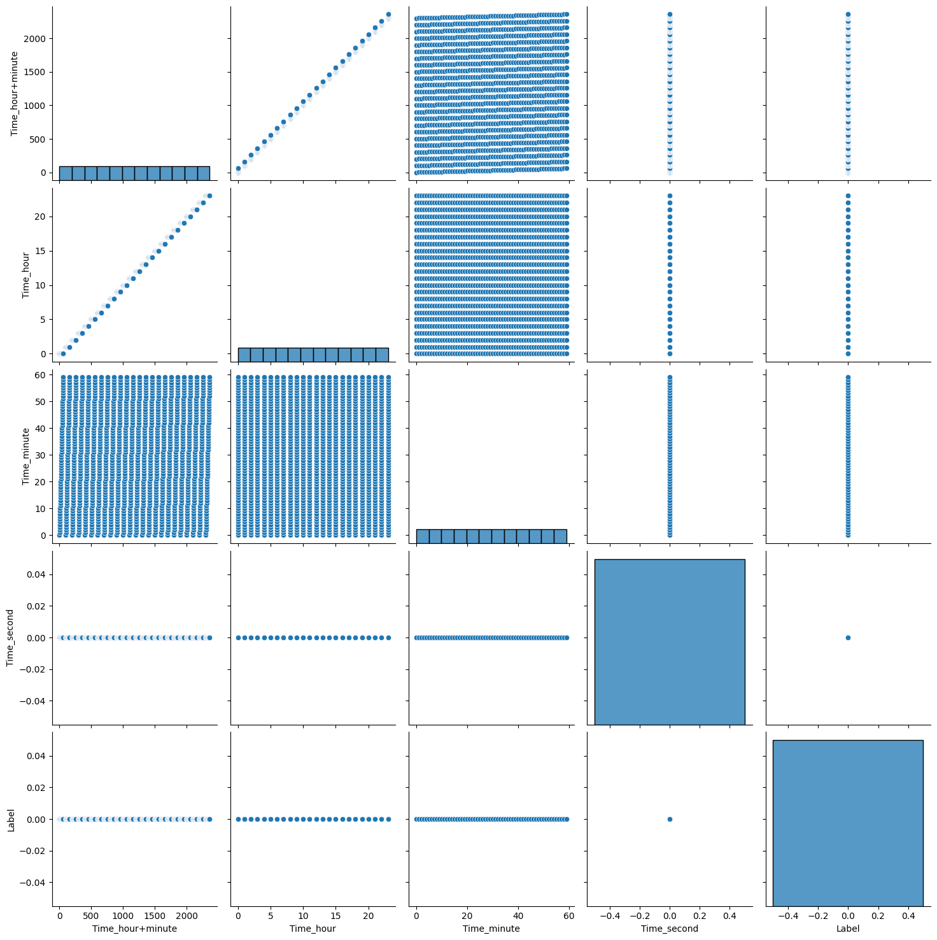

Figure 1: Day 1 traffic (non anomalous)

**RIPE_Code_Red_I**

This dataset has total of 5 days of traffic. Day 1 & 2 traffic is non anomalous as shown in Figure *2*. Day 3 traffic which is the day of attack has both anomalous and non anomalous traffic as shown in Figure *3*. Figure *4* has day 4 & 5 traffic which is non anomalous.

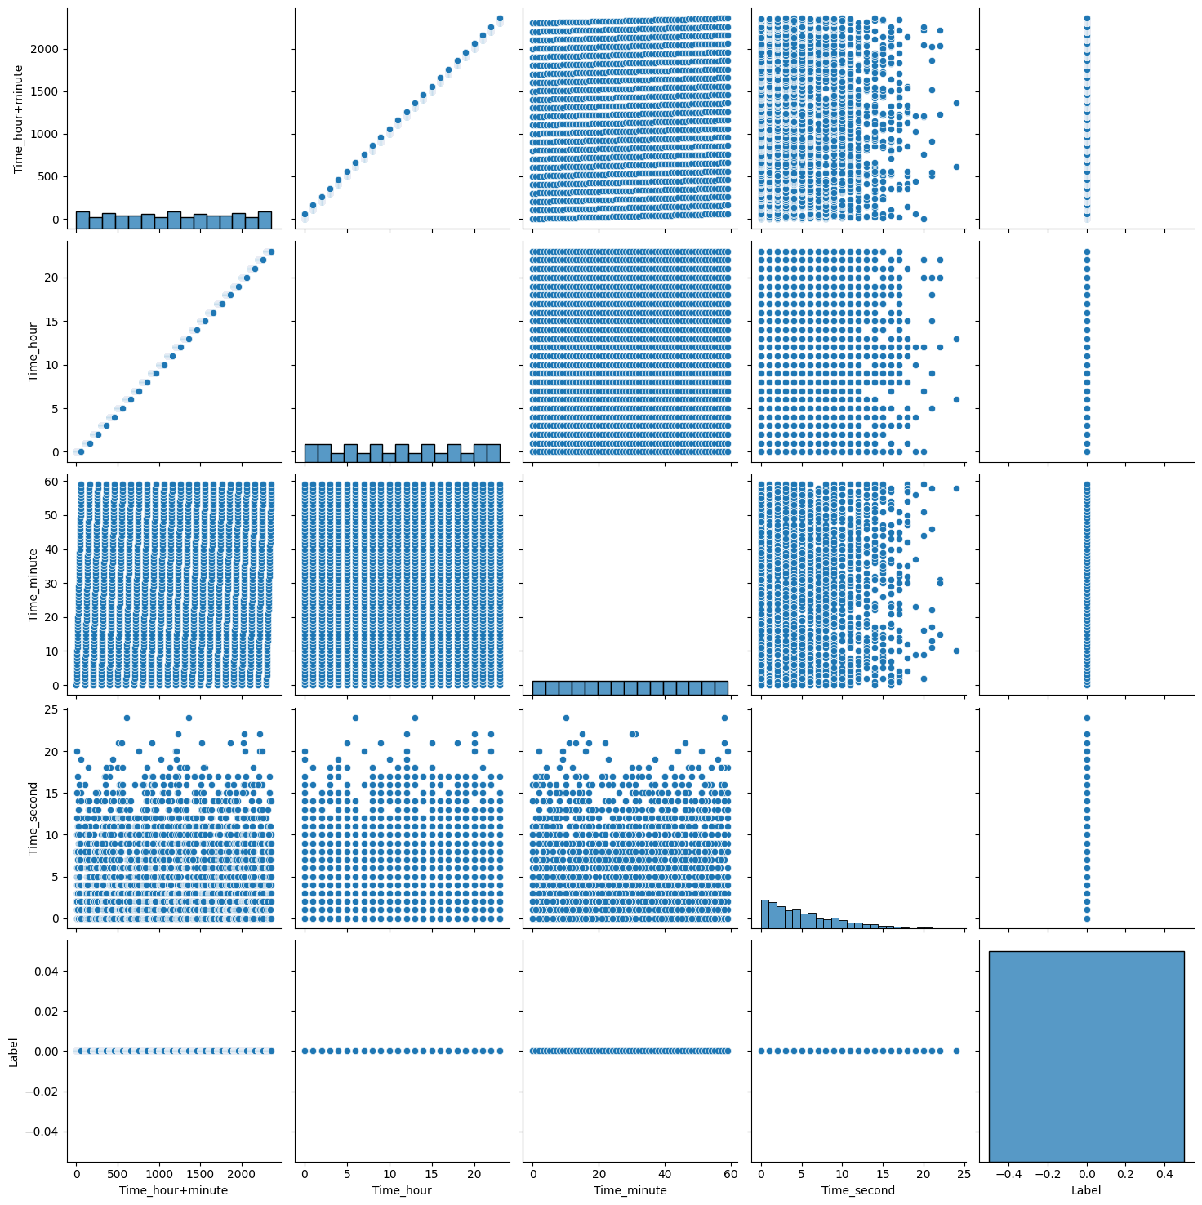

Figure 2: Day 1 & 2 traffic (non anomalous)

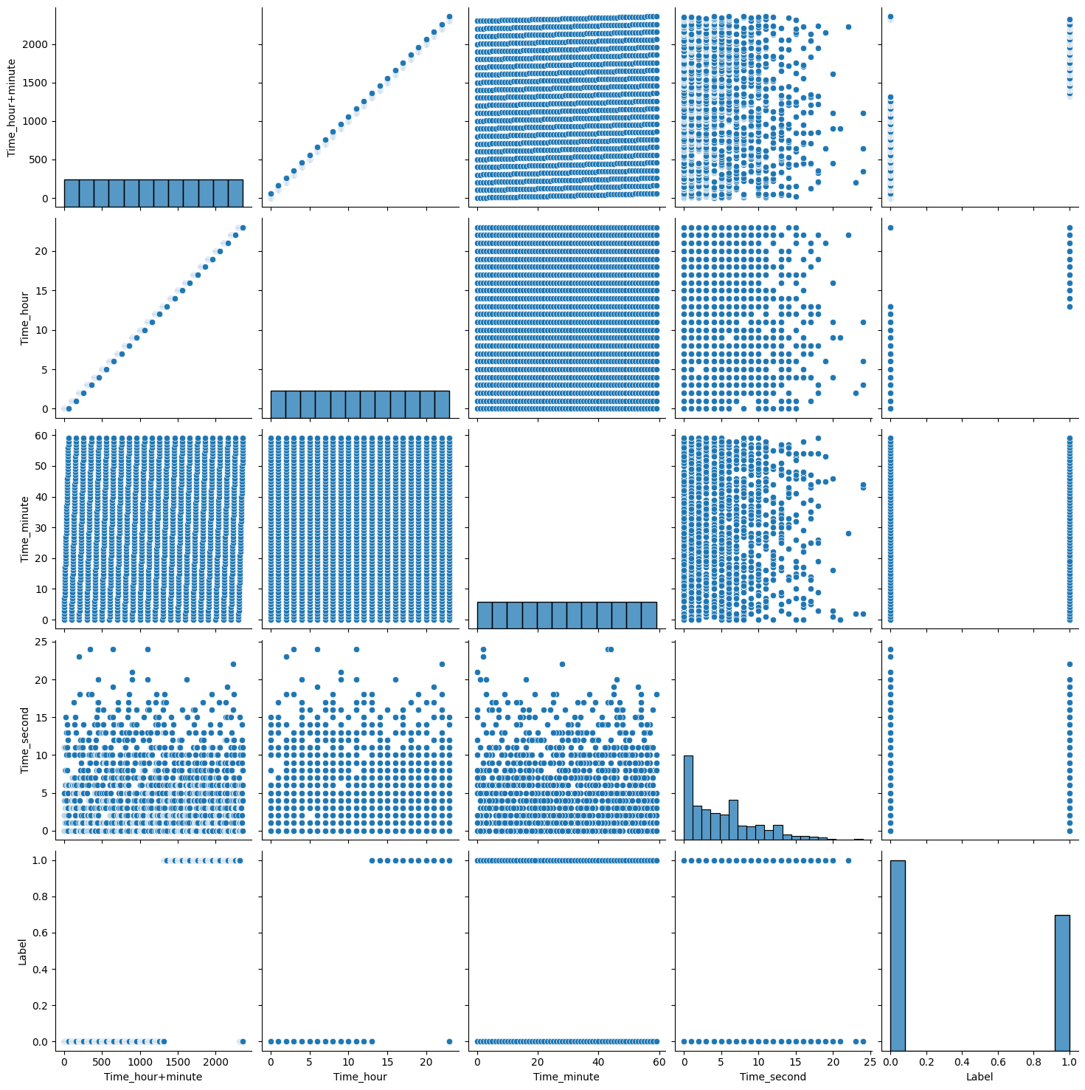

Figure 3: Day 3 traffic (non anamolous and anomalous)

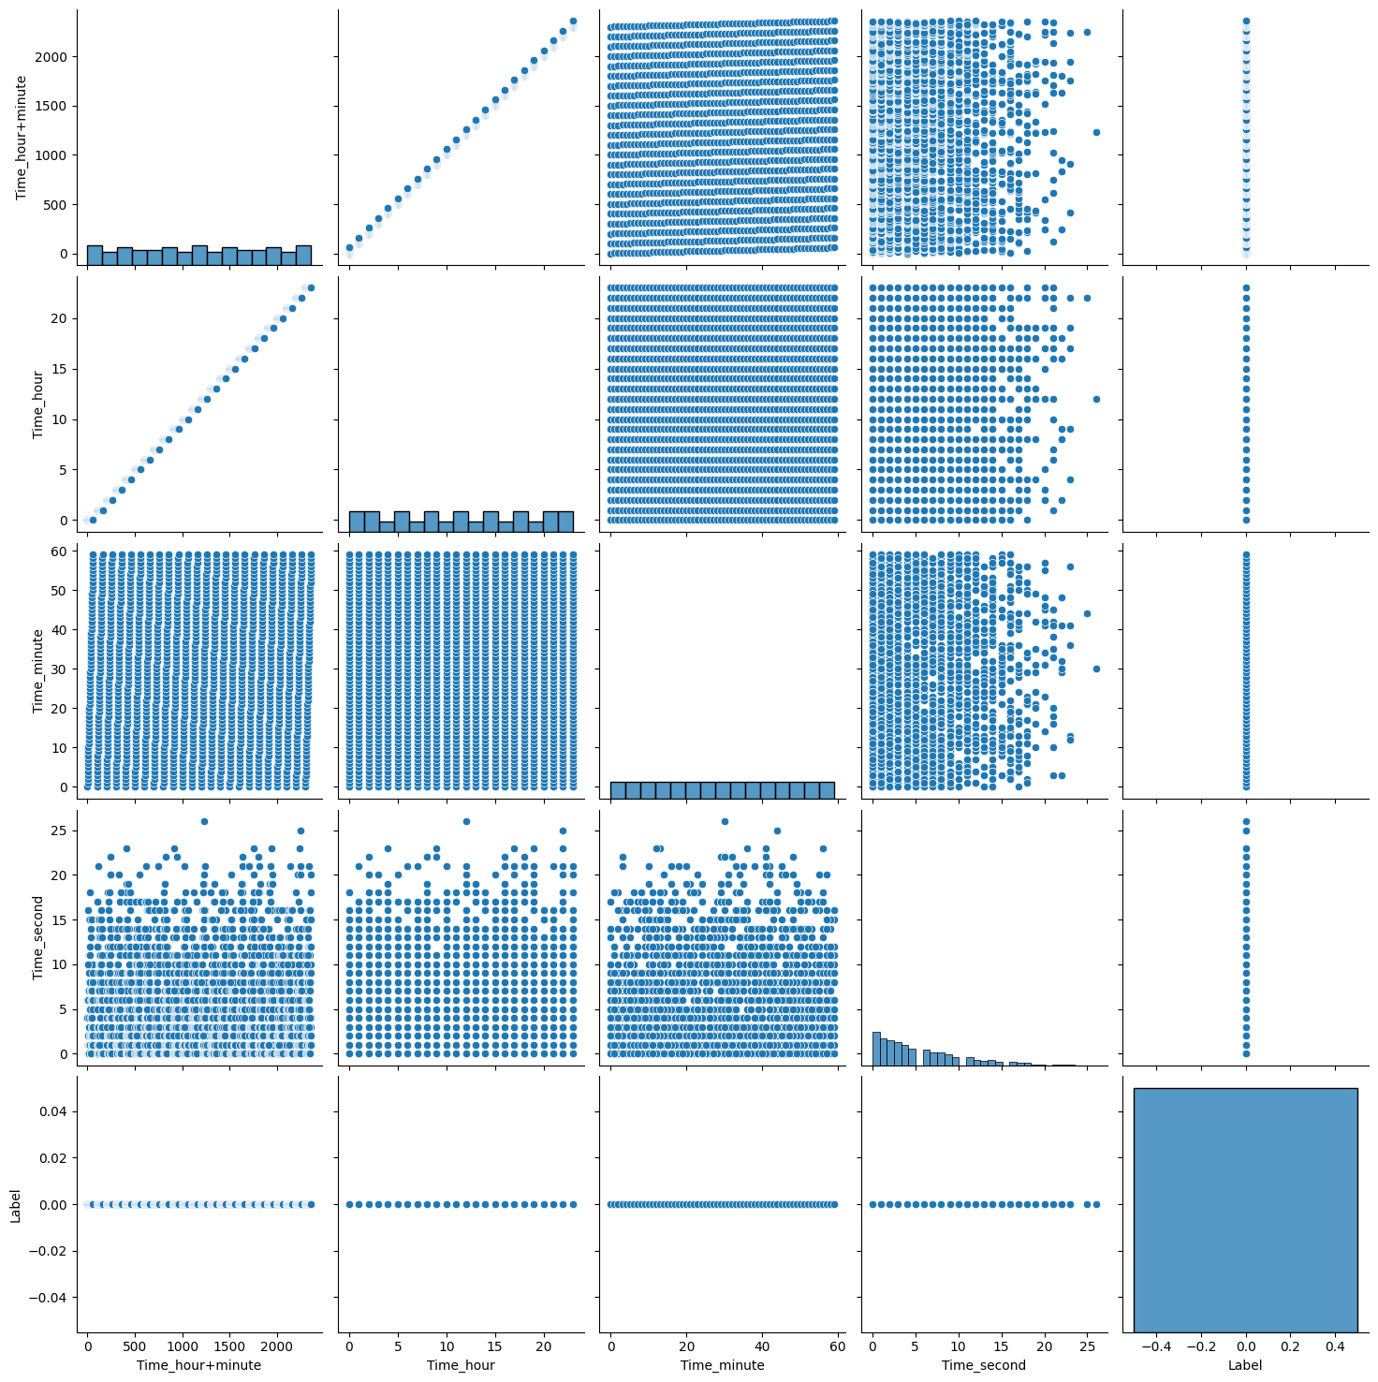

Figure 4: Day 4 & 5 traffic (non anomalous)

**RIPE_Moscow_blackout**

This dataset has total of 5 days of traffic. Day 1 & 2 traffic is non anomalous as shown in Figure *5*. Day 3 traffic which is the day of attack has both anomalous and non anomalous traffic as shown in Figure *6*. Figure *7* has day 4 & 5 traffic which is non anomalous.

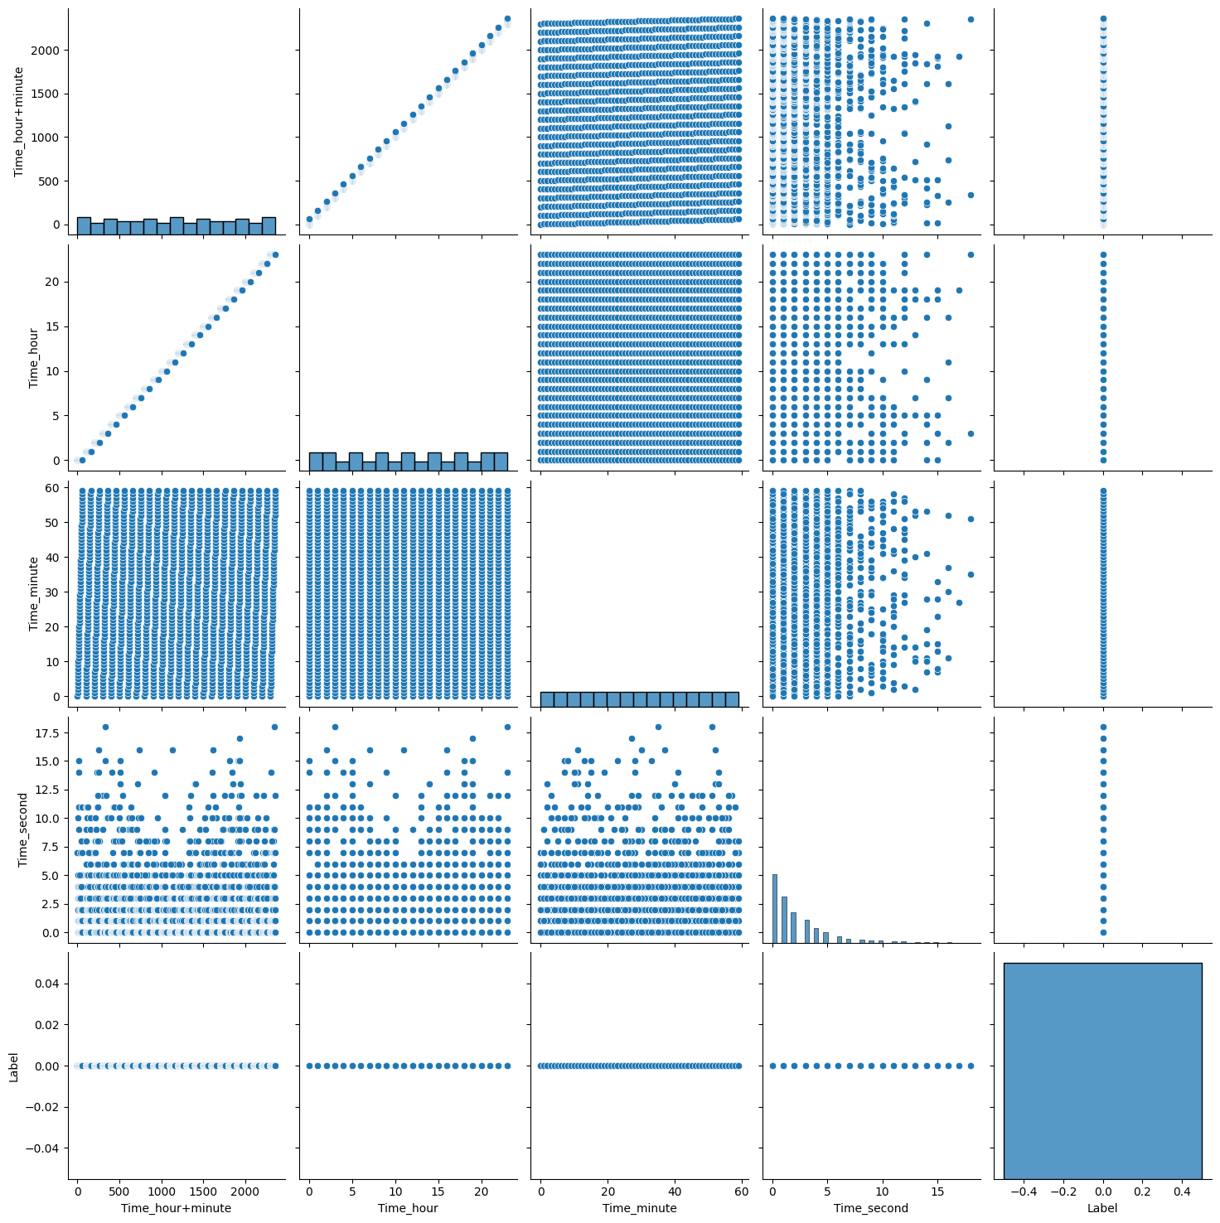

Figure 5: Day 1 & 2 traffic (non anomalous)

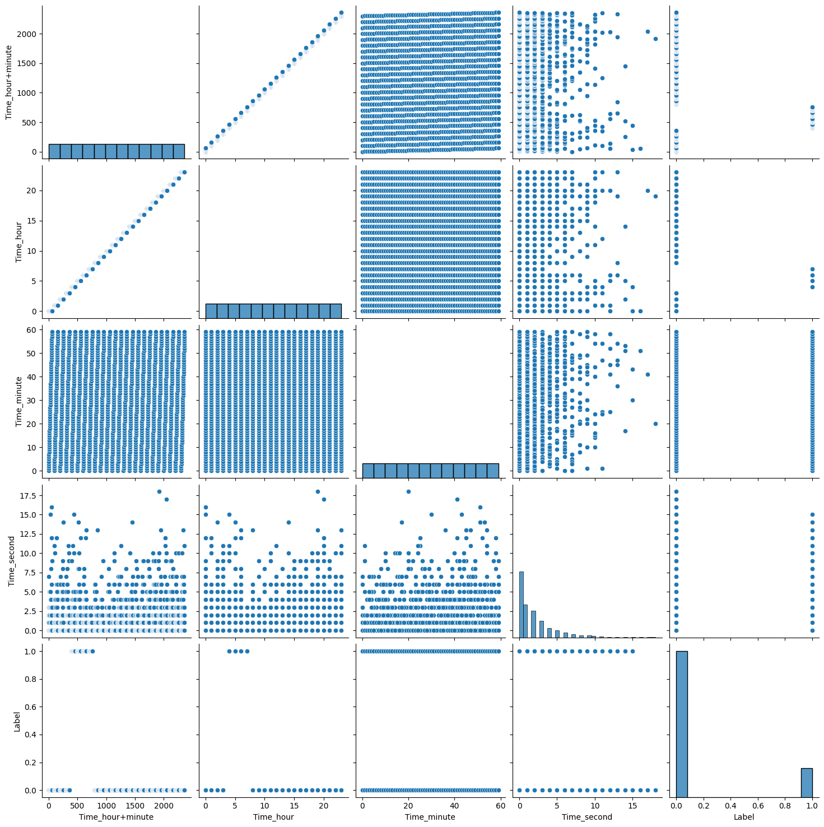

Figure 6: Day 3 traffic (non anomalous and anomalous)

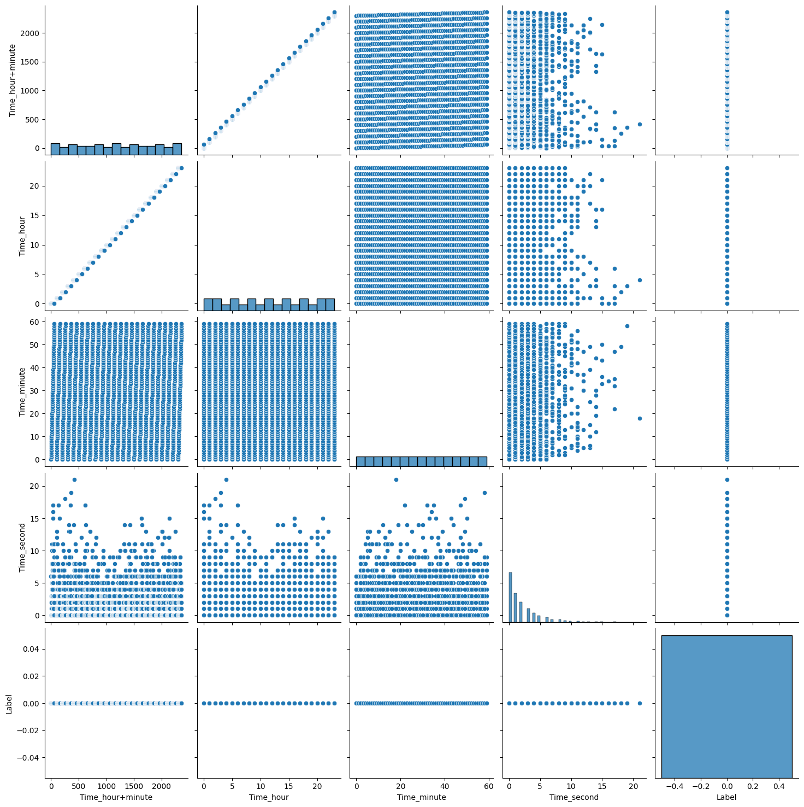

Figure 7: Day 4 & 5 traffic (non anomalous)

**RIPE_Nimda**

This dataset has total of 6 days of traffic. Day 1 & 2 traffic is non anomalous as shown in Figure *8*. Day 3 & 4 traffic which is the day of attack has both anomalous and non anomalous traffic as shown in Figure *9*. Figure *10* has day 5 & 6 traffic which is non anomalous.

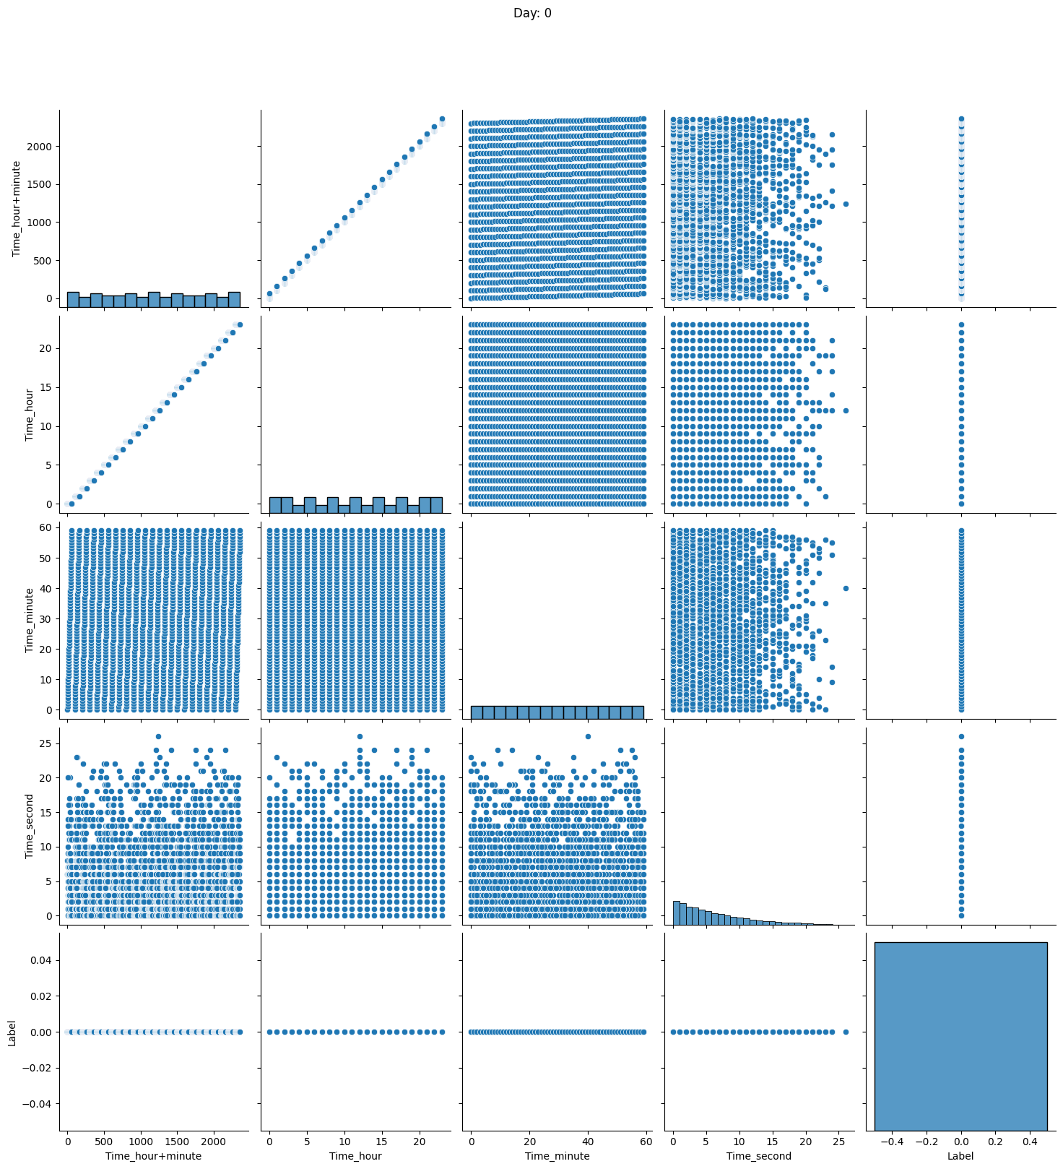

Figure 8: Day 1 & 2 traffic (non anomalous)

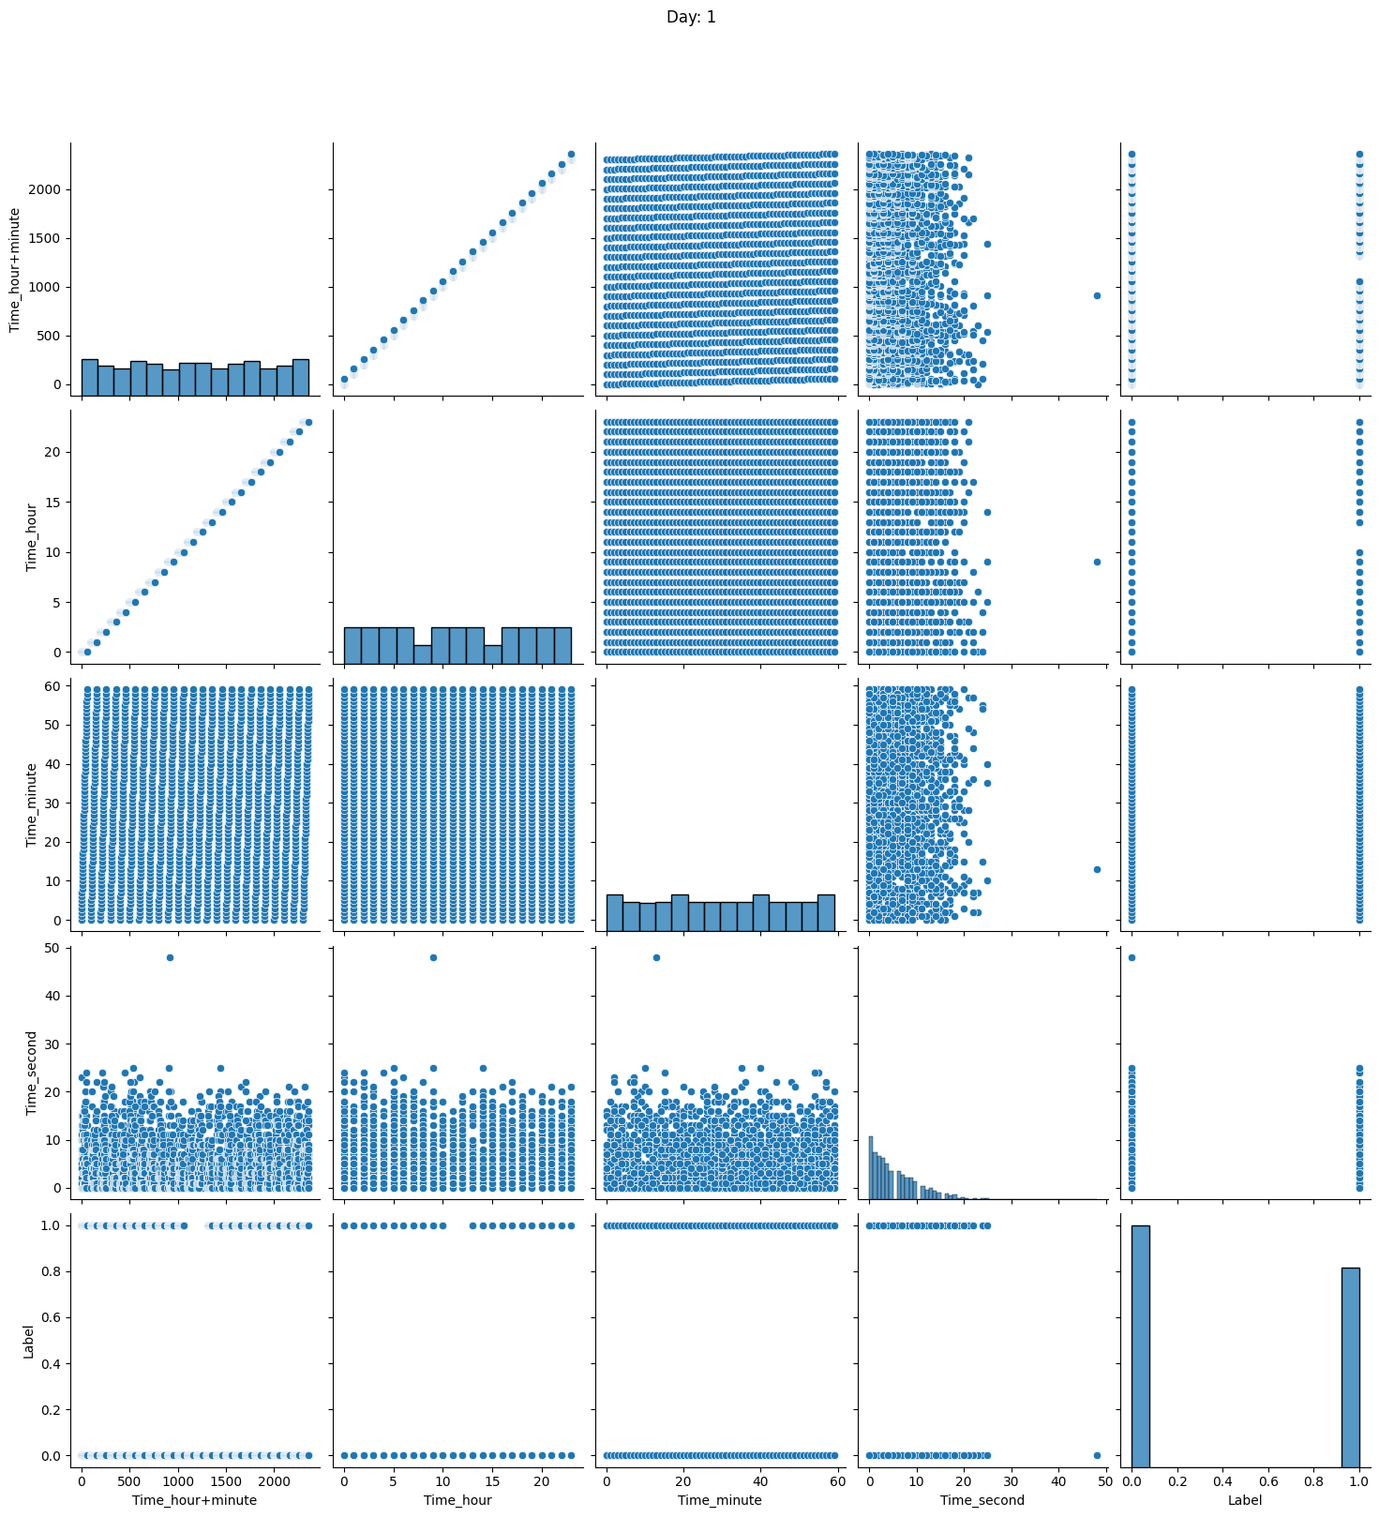

Figure 9: Day 3 & 4 traffic (non anomalous and anamolous)

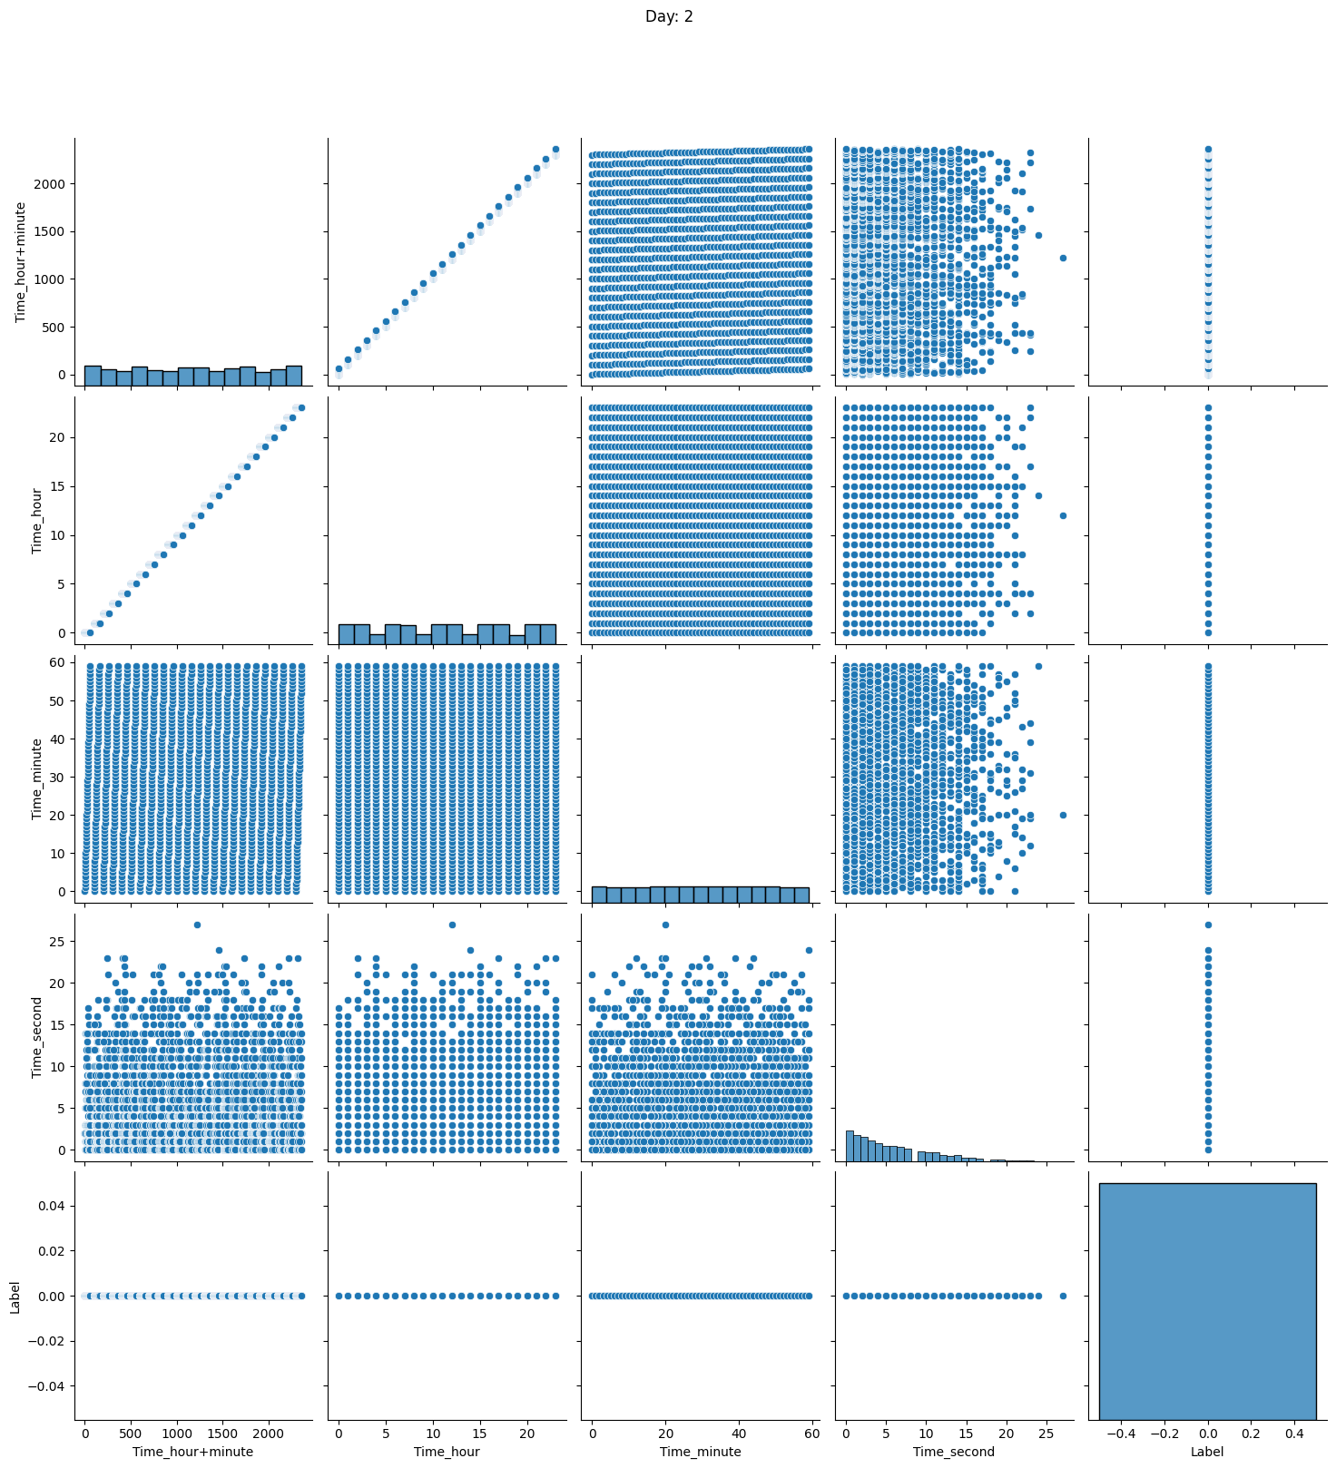

Figure 10: Day 5 & 6 traffic (non anomalous)

**RIPE_regular**

This dataset has four days of traffic which is non anomalous as shown in Figure *11*, *12*, *13*, and *14*

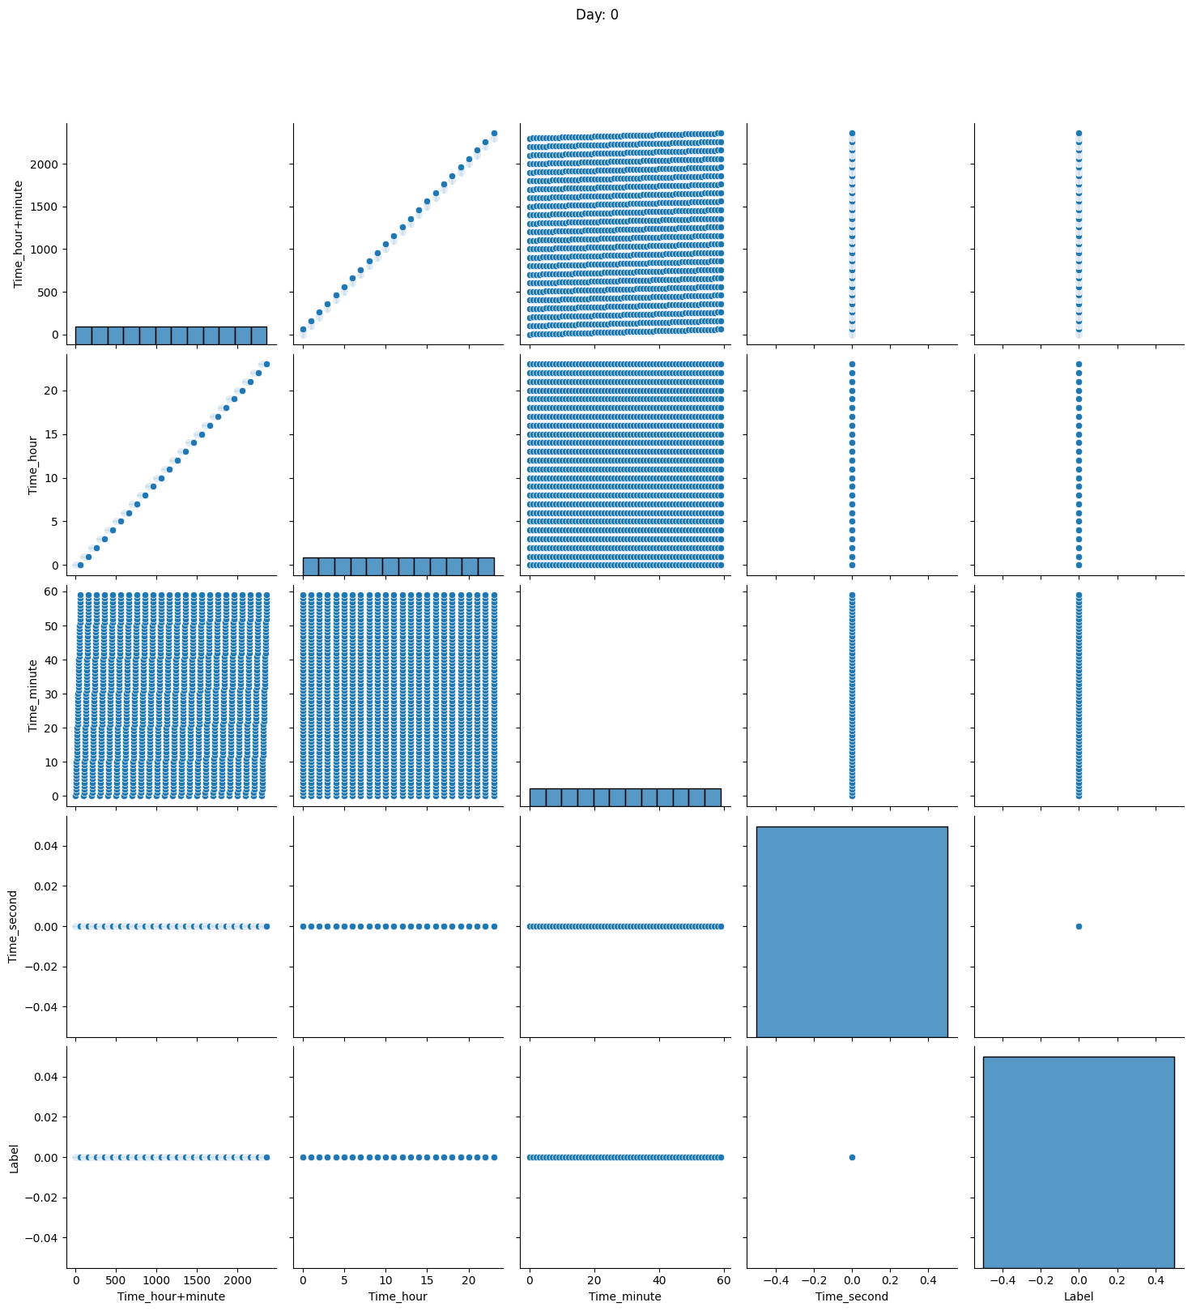

Figure 11: Day 1 traffic (non anomalous)

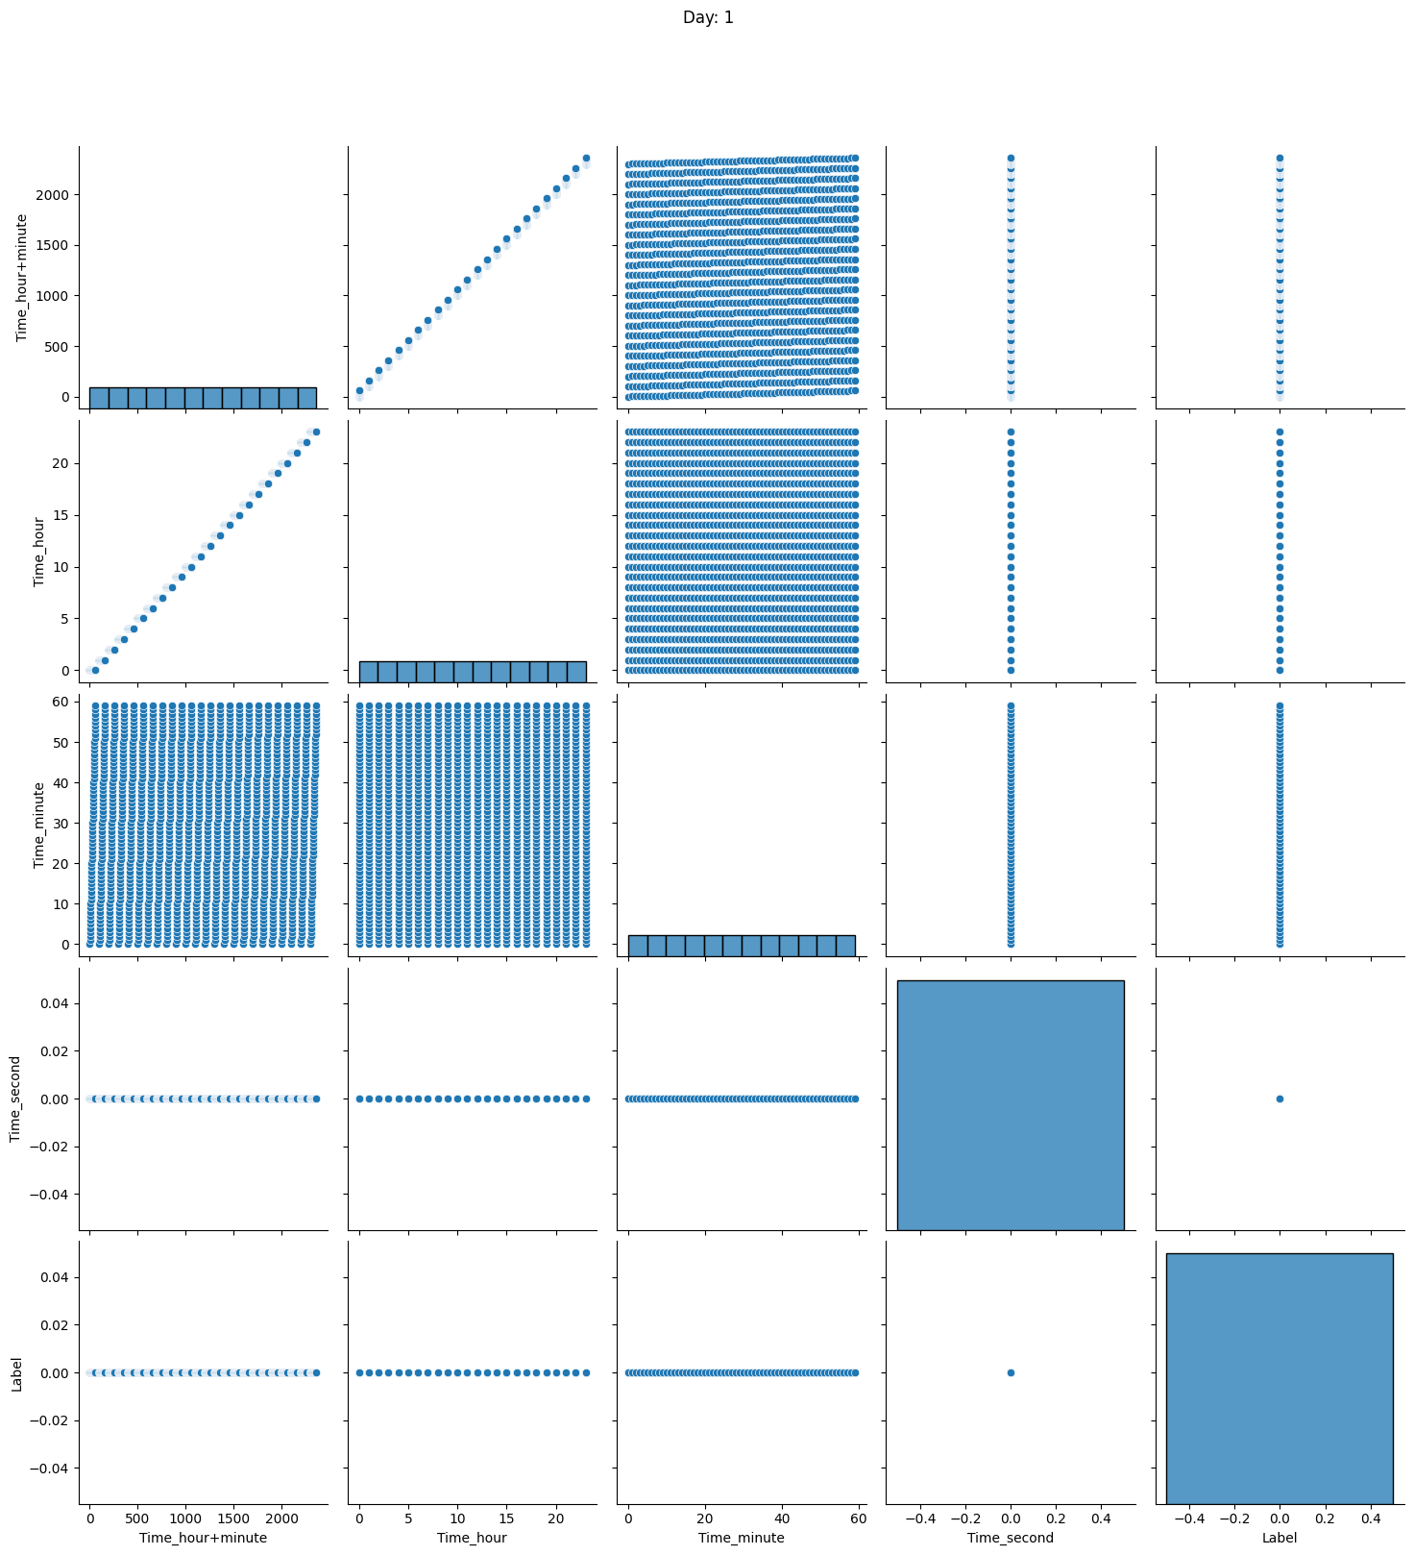

Figure 12: Day 2 traffic (non anomalous)

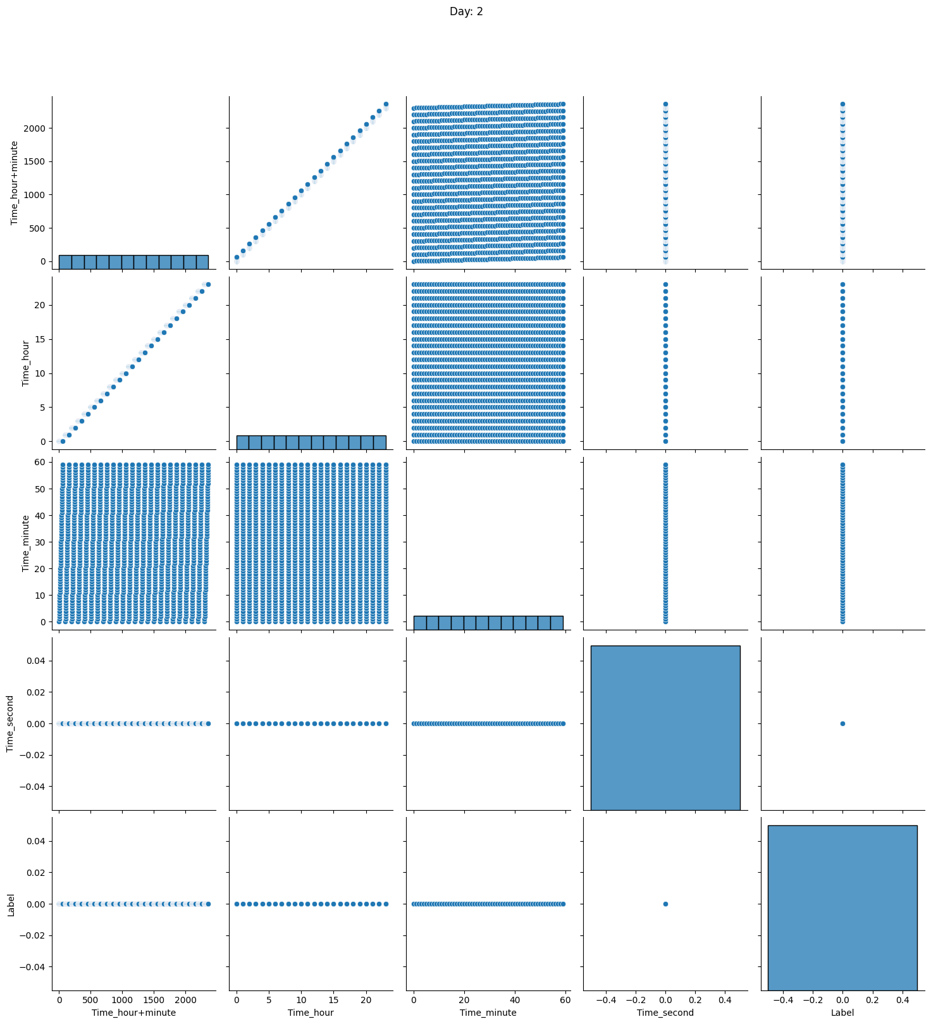

Figure 13: Day 3 traffic (non anomalous)

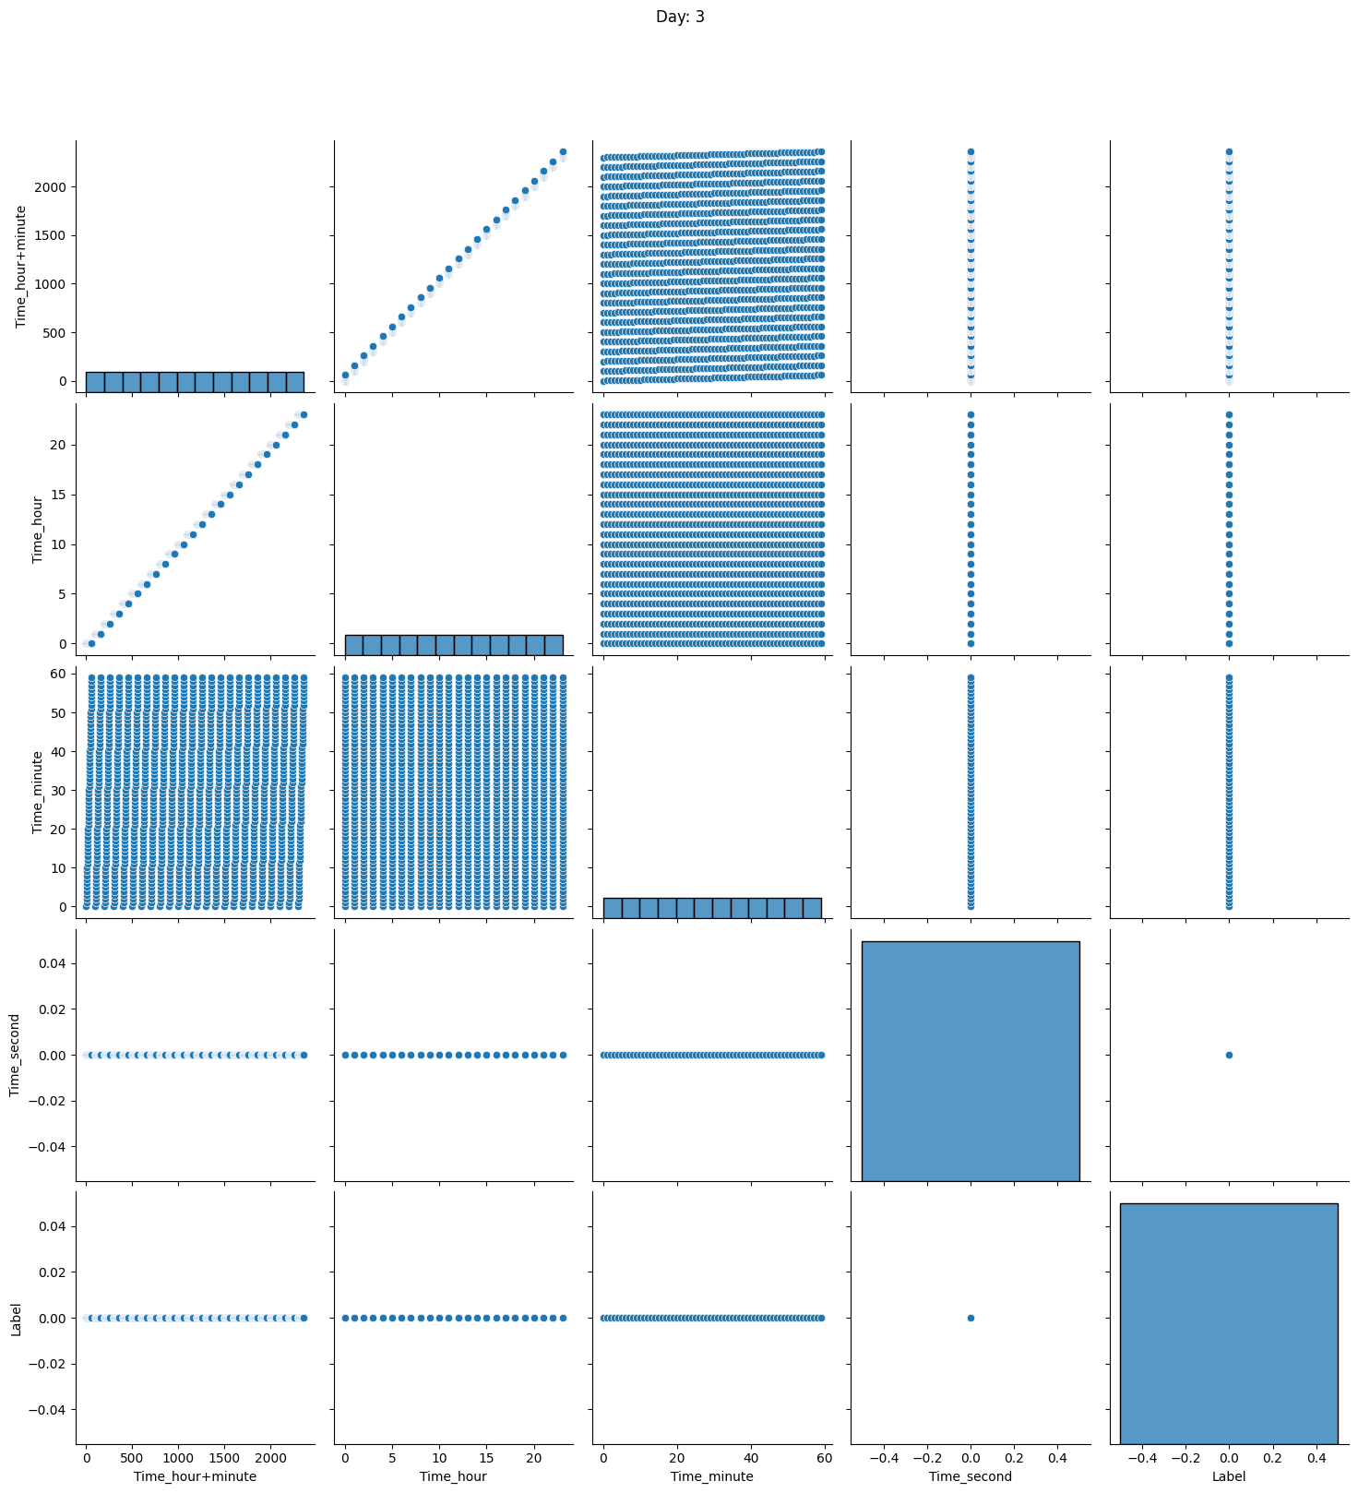

Figure 14: Day 4 traffic (non anomalous)

**RIPE_Slammer**

This dataset has total of 5 days of traffic. Day 1 & 2 traffic is non anomalous as shown in *Figure 15*. Day 3 traffic which is the day of attack has both anomalous and non anomalous traffic as shown in *Figure 16*. *Figure 17* has day 4 & 5 traffic which is non anomalous.

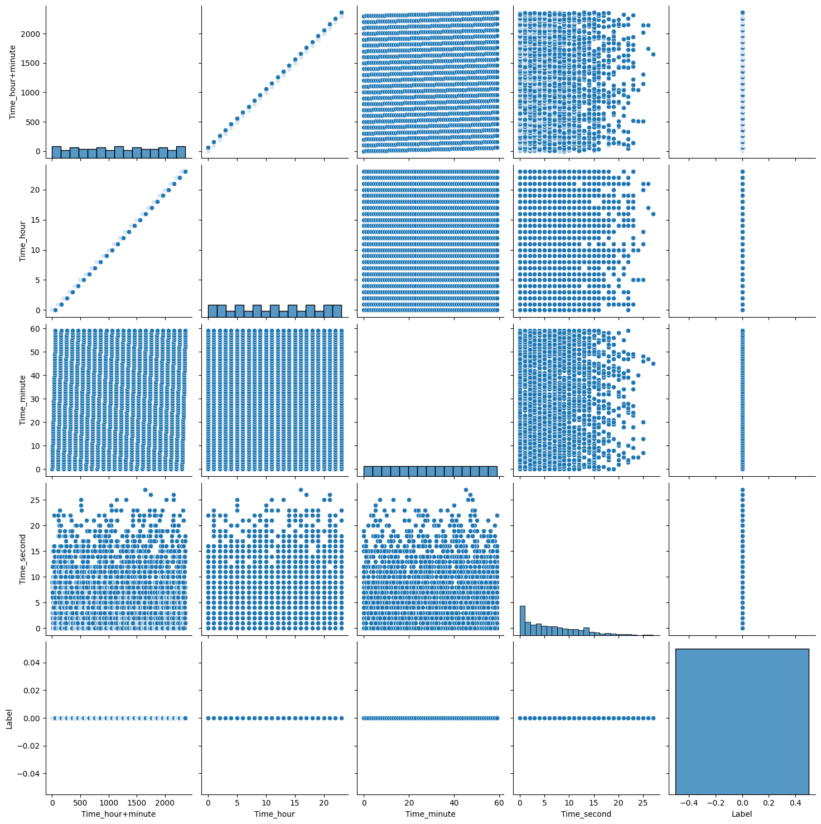

Figure 15: Day 1 & 2 traffic (non anomalous)

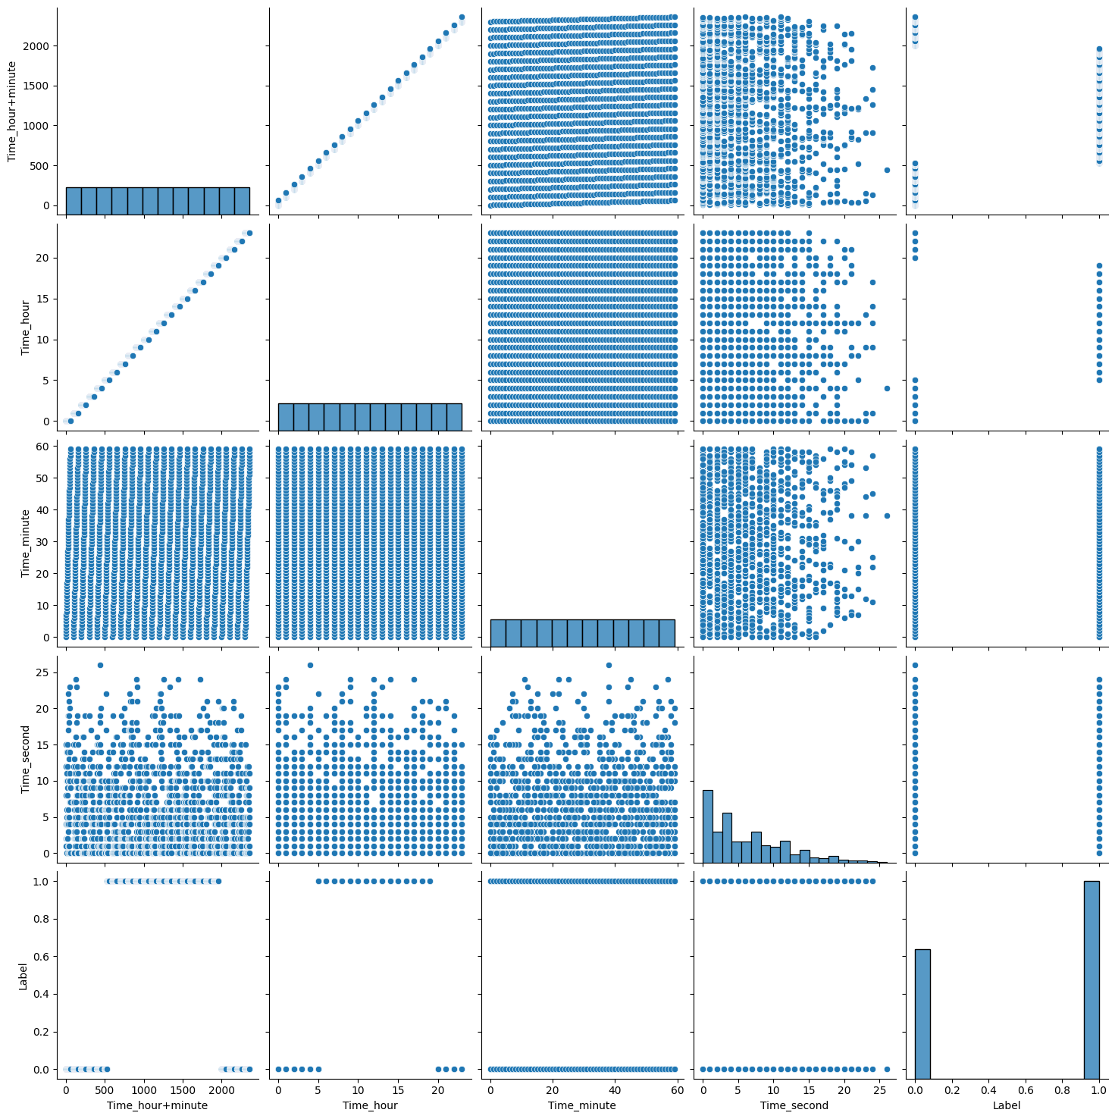

Figure 16: Day 3 traffic (non anomalous and anamolous)

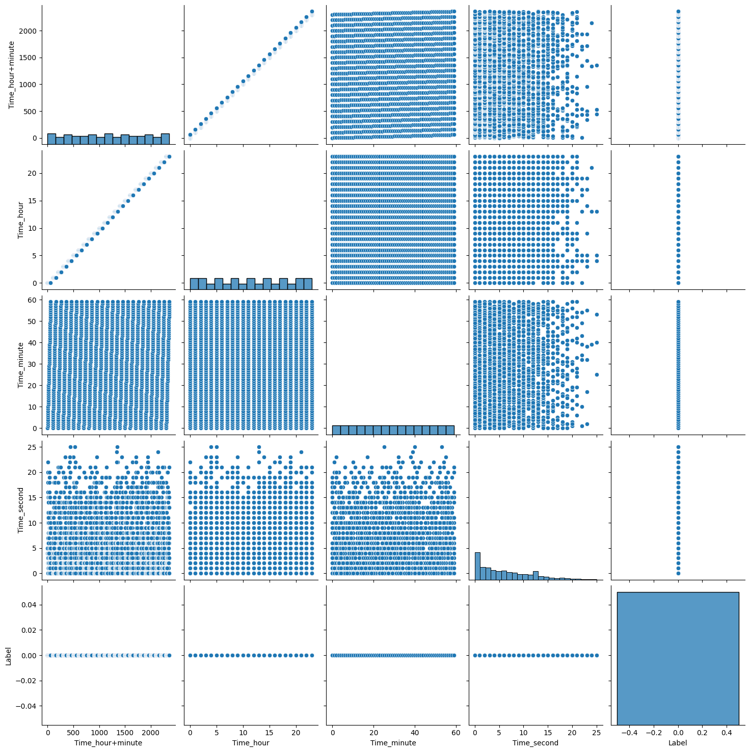

Figure 17: Day 4 & 5 traffic (non anomalous)

**RIPE_WannaCrypt**

This dataset has total of 8 days of traffic. Day 1 & 2 traffic is non anomalous as shown in *Figure 18*. Day 3, 4, 5, & 6 traffic which are the days of attack has anomalous traffic as shown in *Figure 19*. *Figure 20* has day 7 & 8 traffic which is non anomalous.

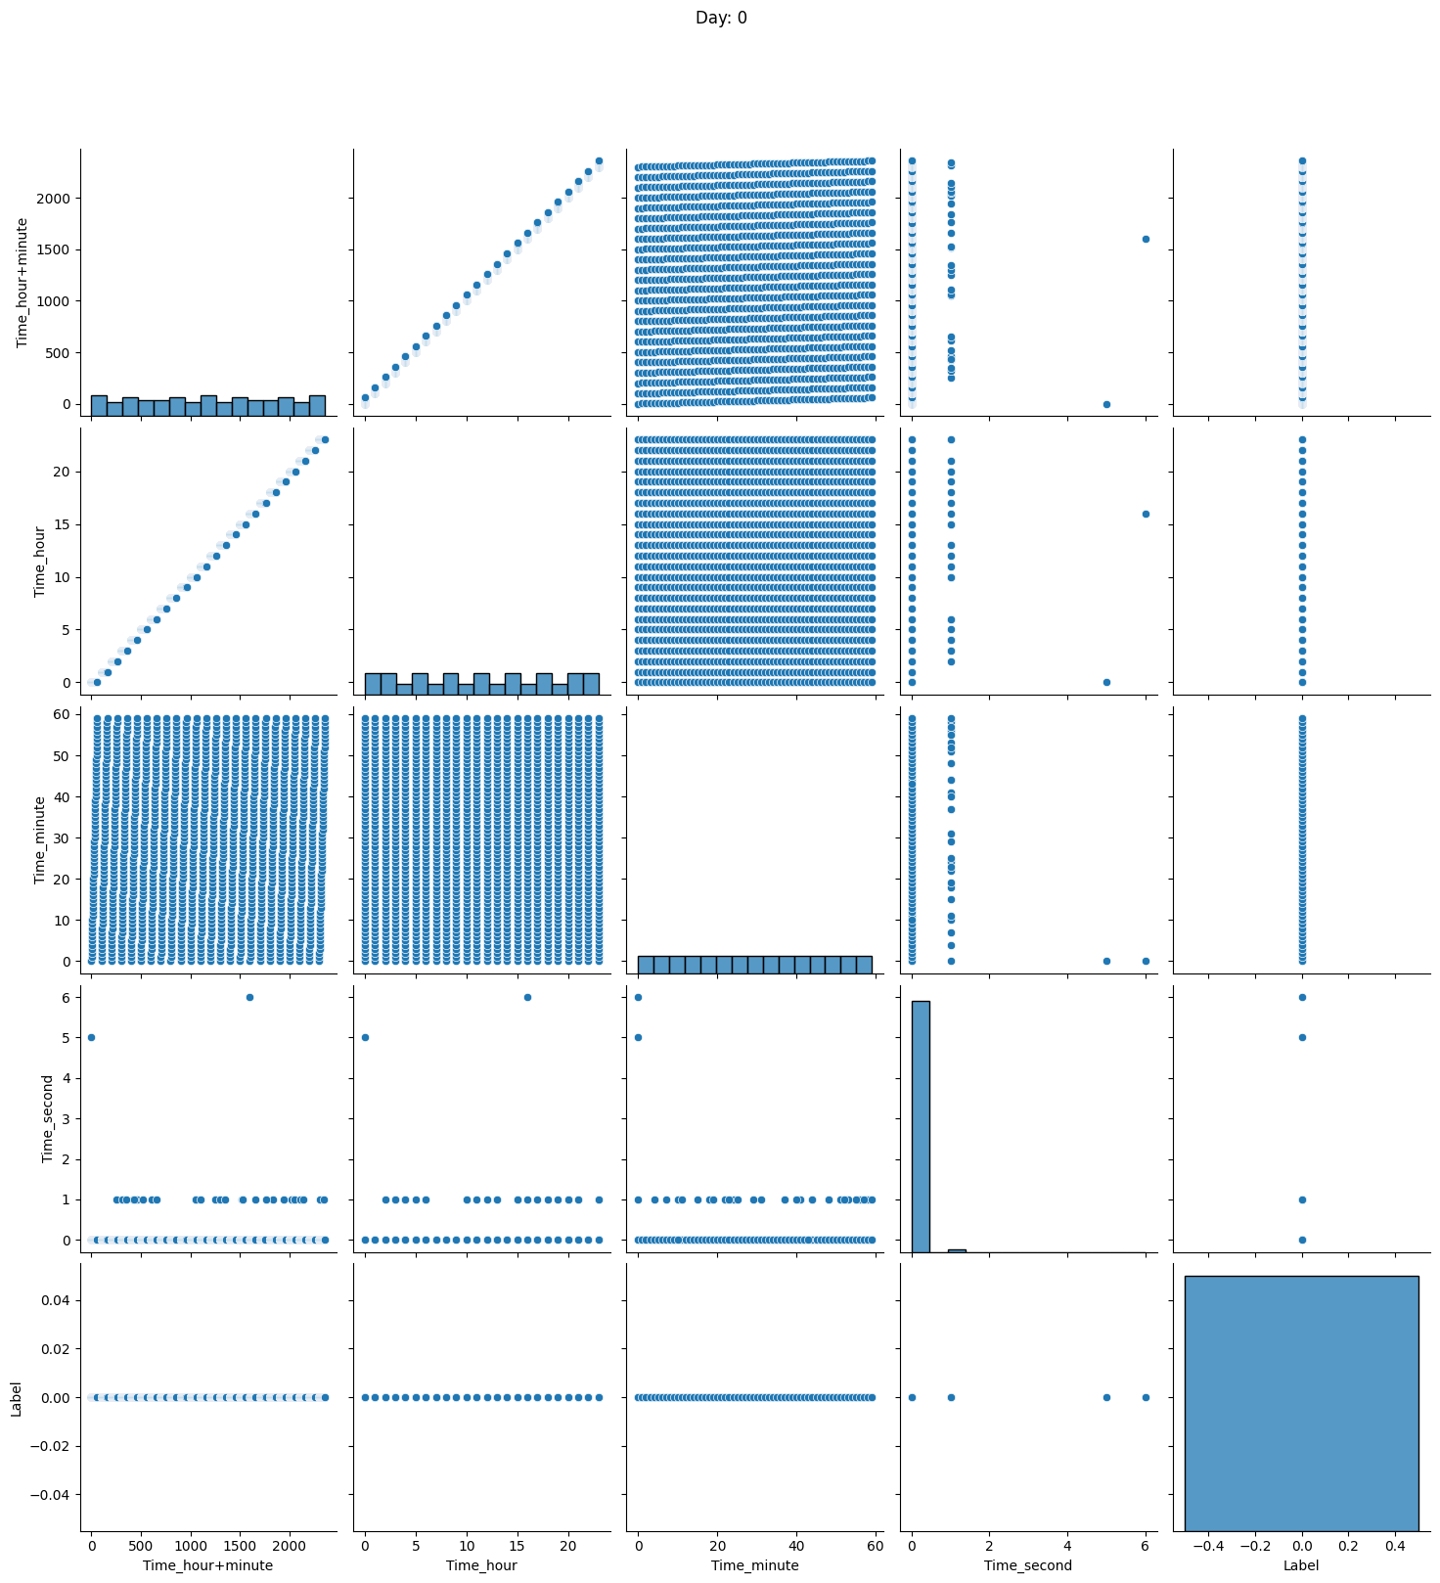

Figure 18: Day 1 & 2 traffic (non anomalous)

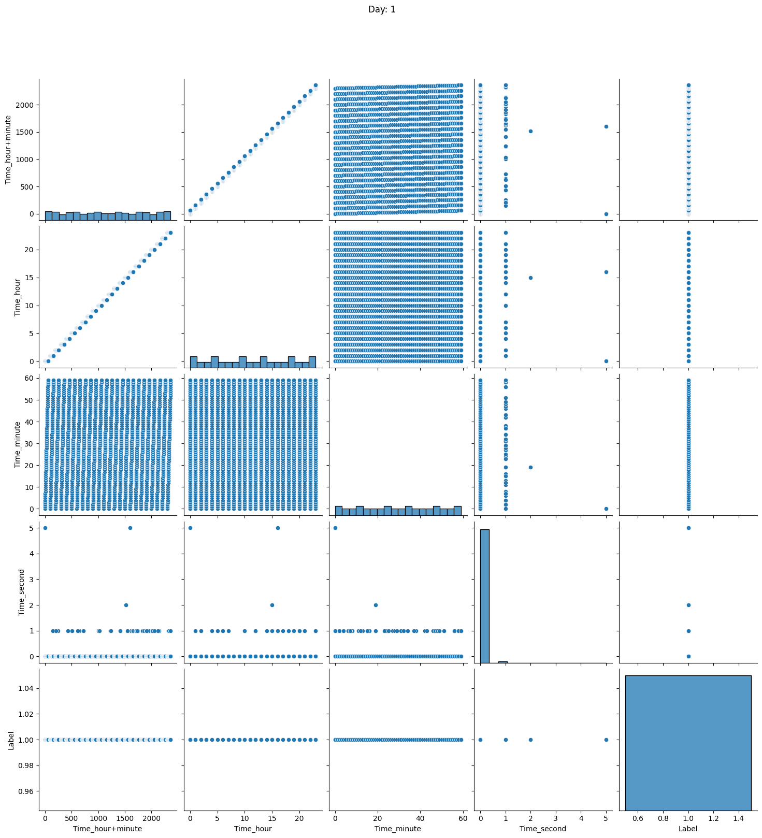

Figure 19: Day 3, 4, 5, & 6 traffic (anomalous)

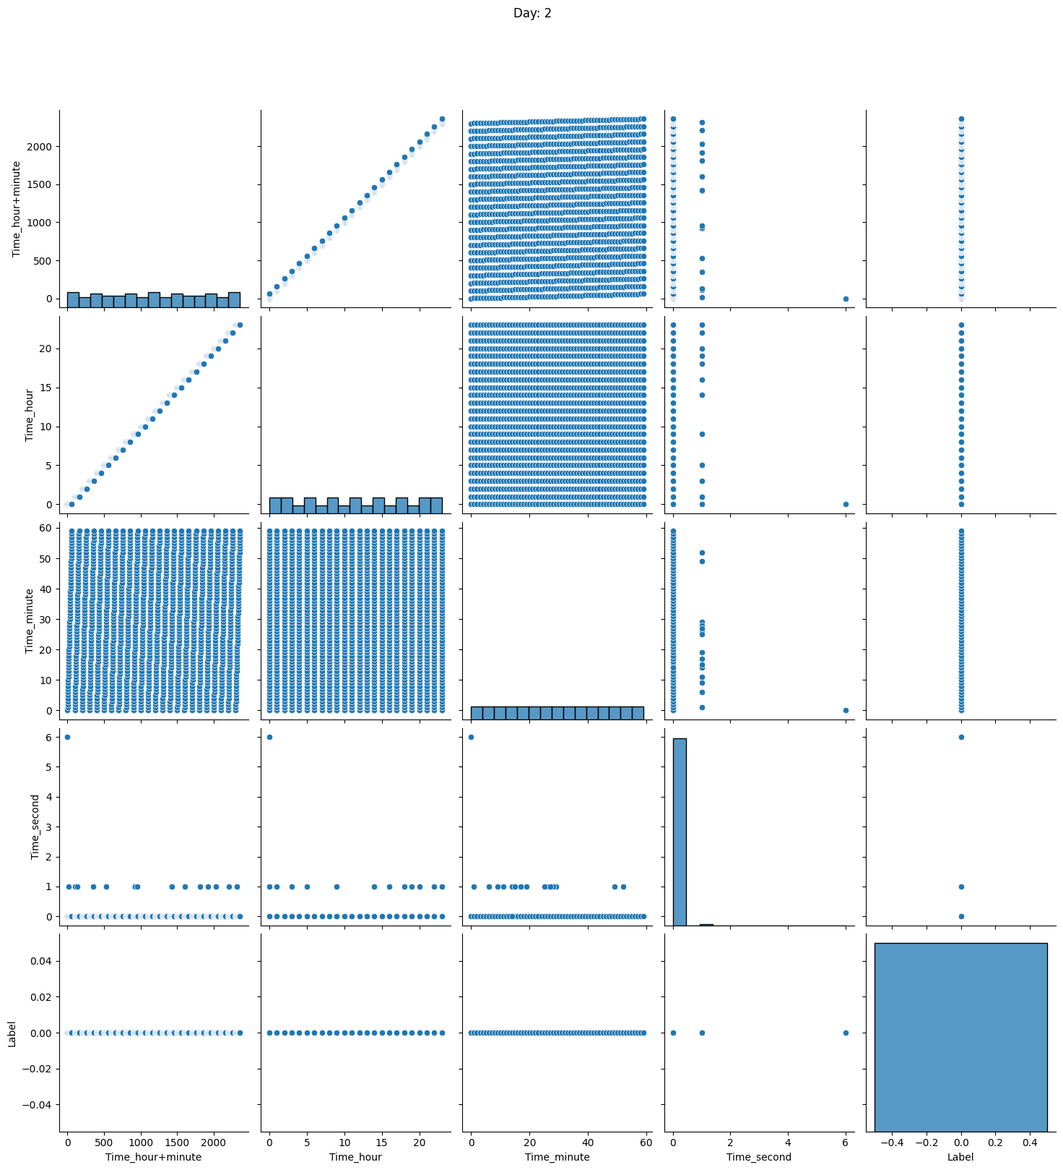

Figure 20: Day 7 & 8 traffic (non anomalous)

**ROUTE VIEWS**

**RouteViews_Moscow_blackout**

This dataset has total of 5 days of traffic. Day 1 & 2 traffic is non anomalous as shown in Figure *21*. Day 3 traffic which is the day of attack has both anomalous and non anomalous traffic as shown in Figure *22*. Figure *23* has day 4 & 5 traffic which is non anomalous.

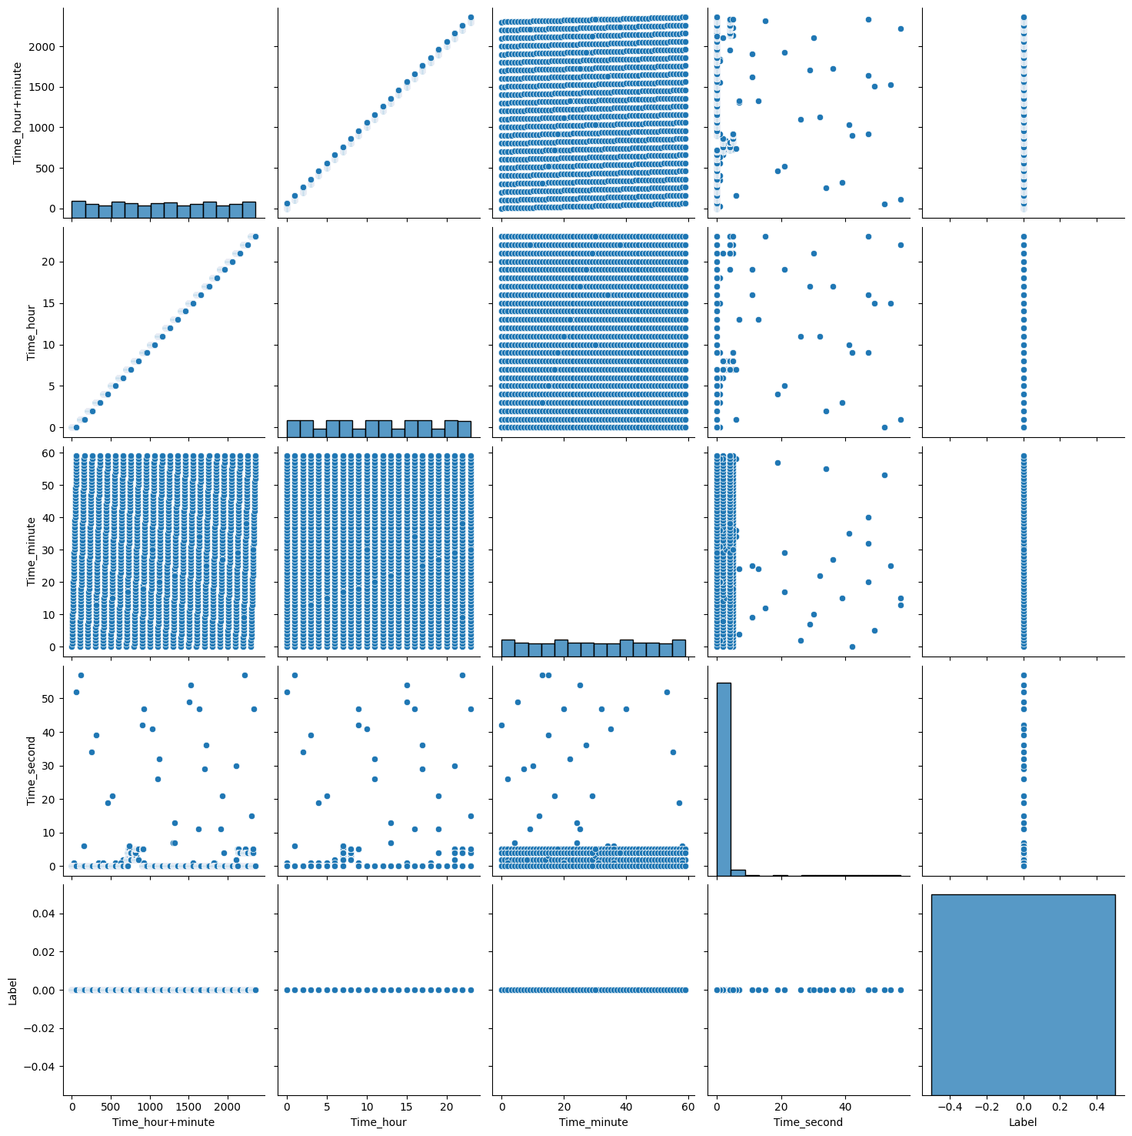

Figure 21: Day 1 & 2 traffic (non anomalous)

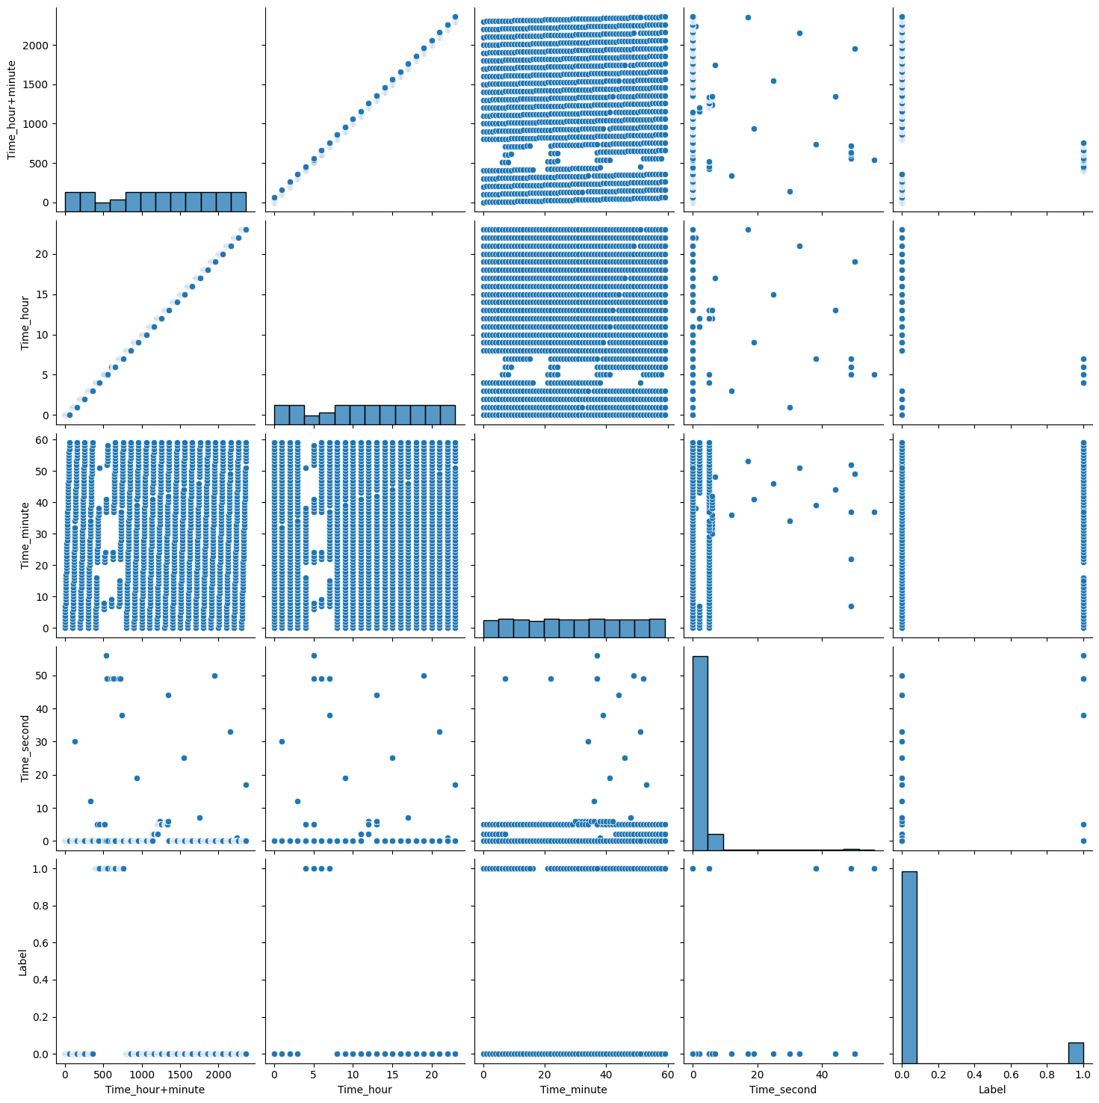

Figure 22: Day 3 traffic (non anomalous and anomalous)

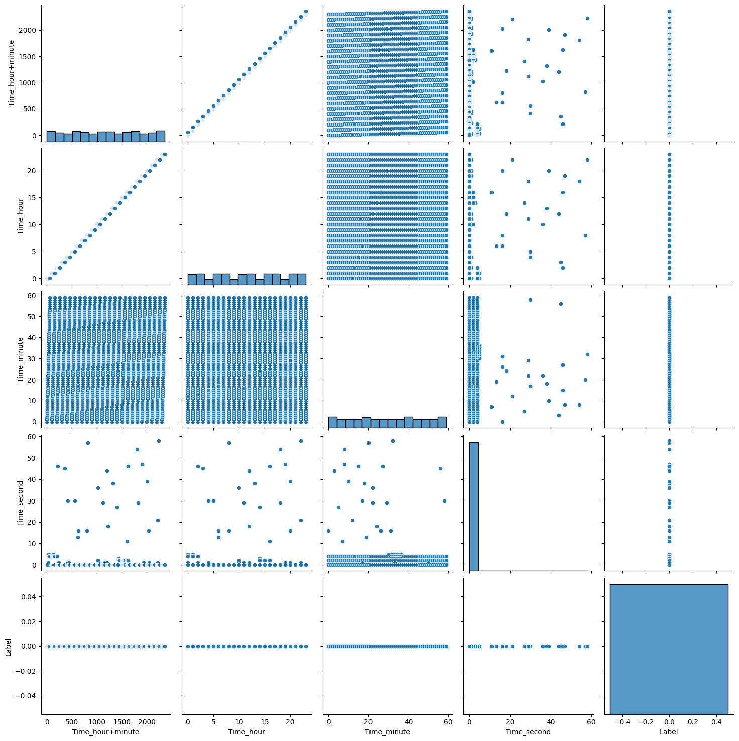

Figure 23: Day 4 & 5 traffic (non anomalous)

**RouteViews_Slammer**

This dataset has total of 5 days of traffic. Day 1 & 2 traffic is non anomalous as shown in Figure *24*. Day 3 traffic which is the day of attack has both anomalous and non anomalous traffic as shown in Figure *25*. Figure *26* has day 4 & 5 traffic which is non anomalous.

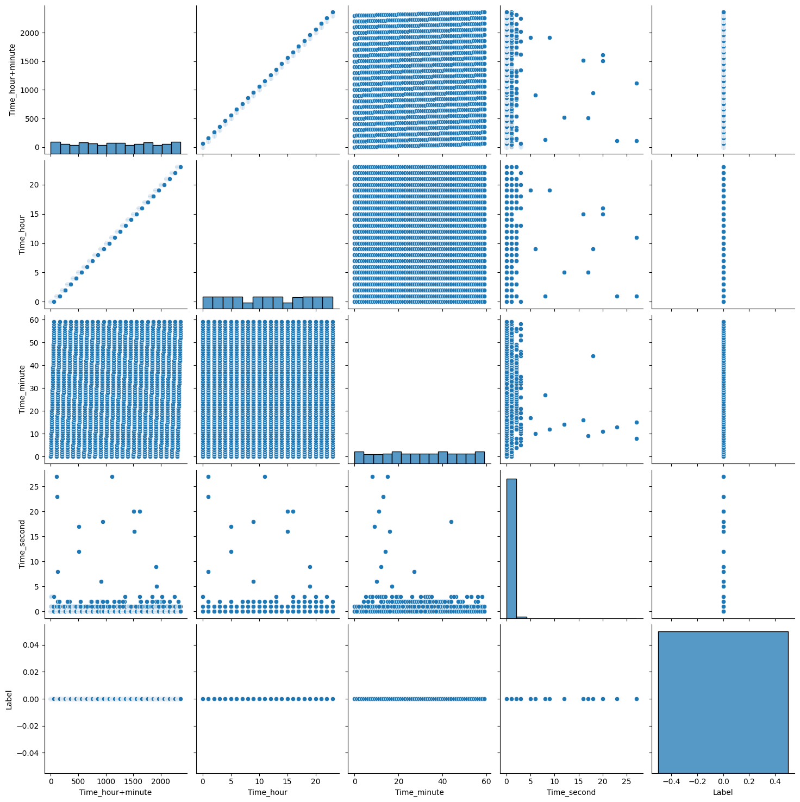

Figure 24: Day 1 & 2 traffic (non anomalous)

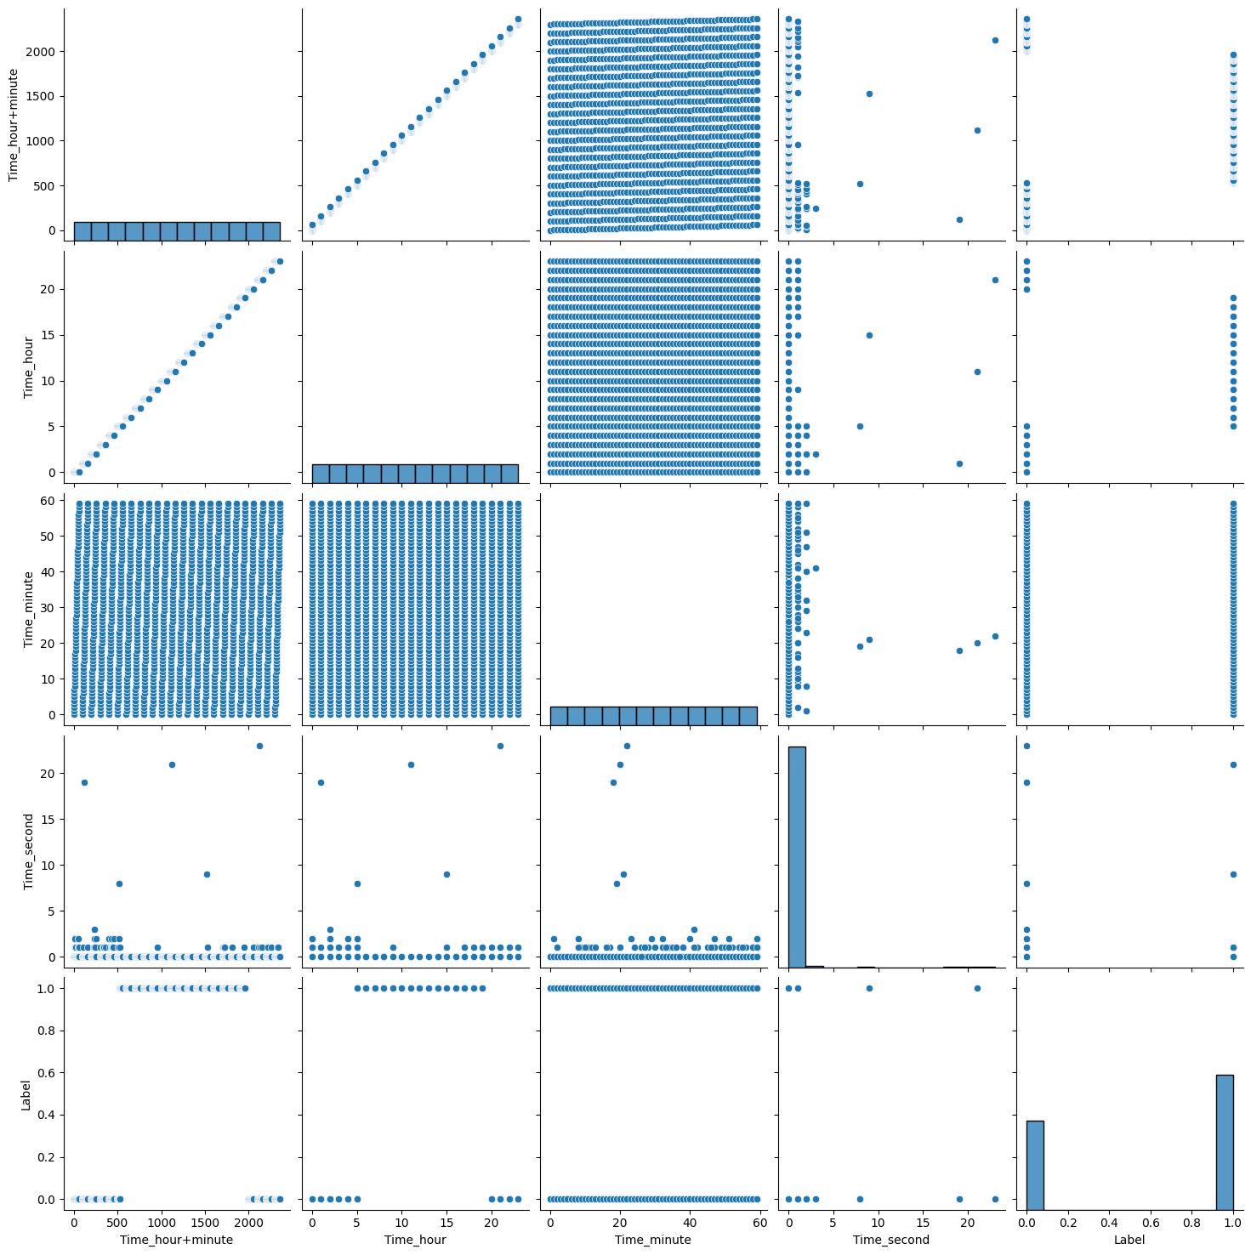

Figure 25: Day 3 traffic (non anomalous and anomalous)

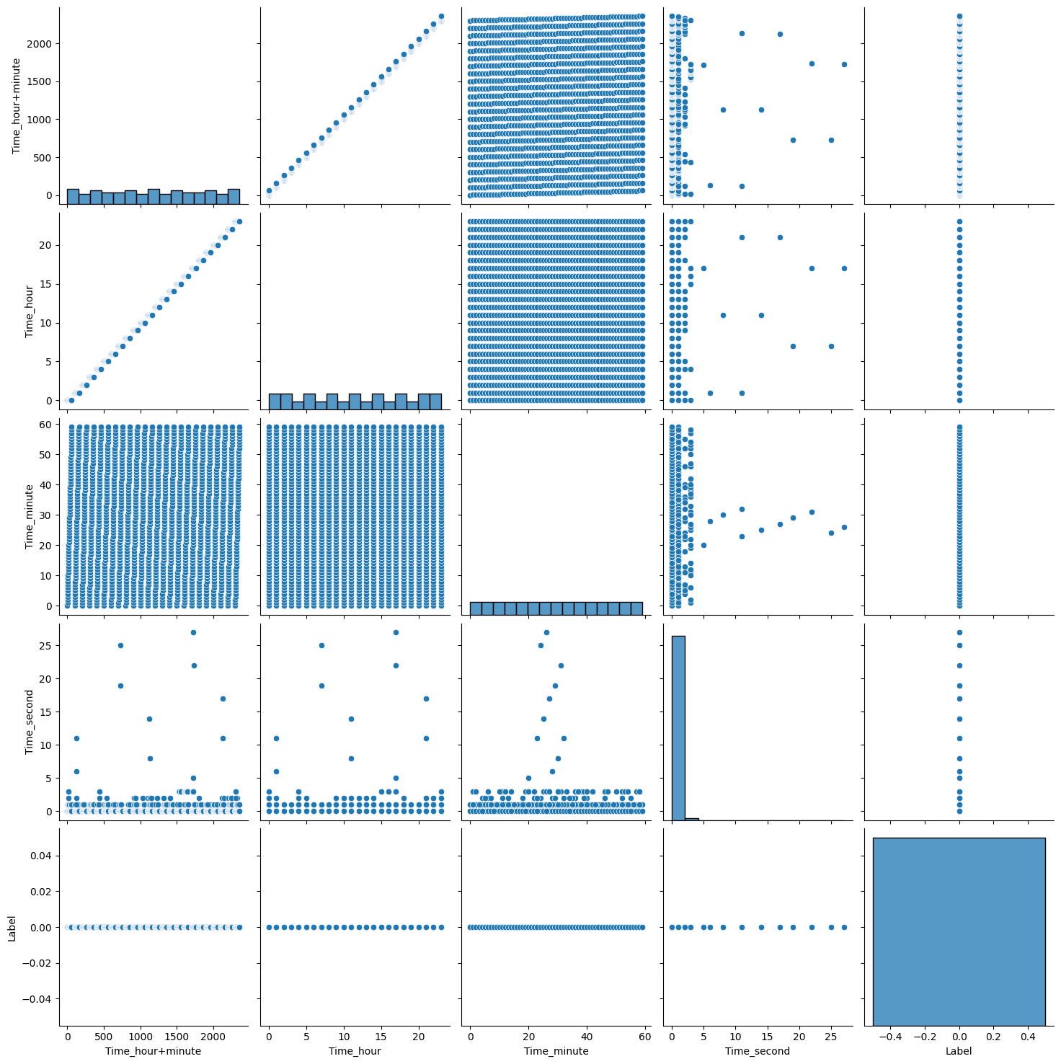

Figure 26: Day 4 & 5 traffic (non anomalous)

**RouteViews_WannaCrypt**

This dataset has total of 8 days of traffic. Day 1 & 2 traffic is non anomalous as shown in Figure *27*. Day 3, 4, 5, & 6 traffic which are the days of attack has both anomalous and non anomalous traffic as shown in Figure *28*. Figure *29* has day 7 & 8 traffic which is non anomalous.

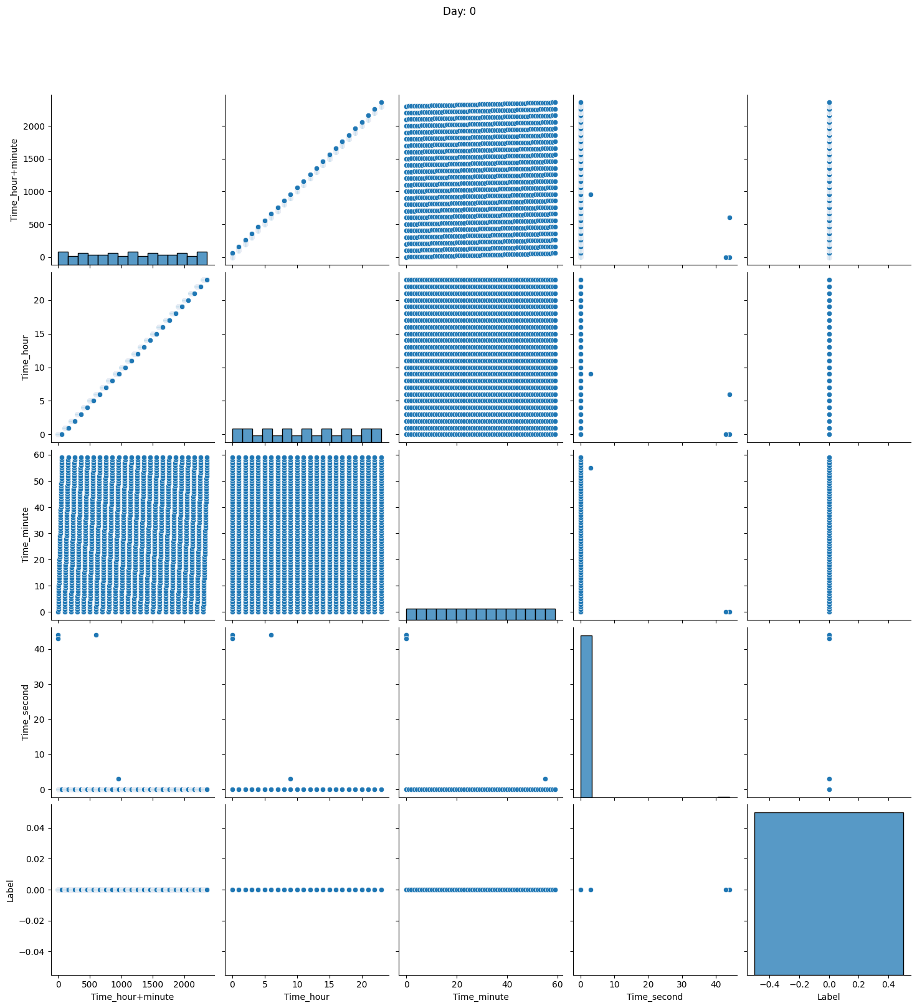

Figure 27: Day 1 & 2 traffic (non anomalous)

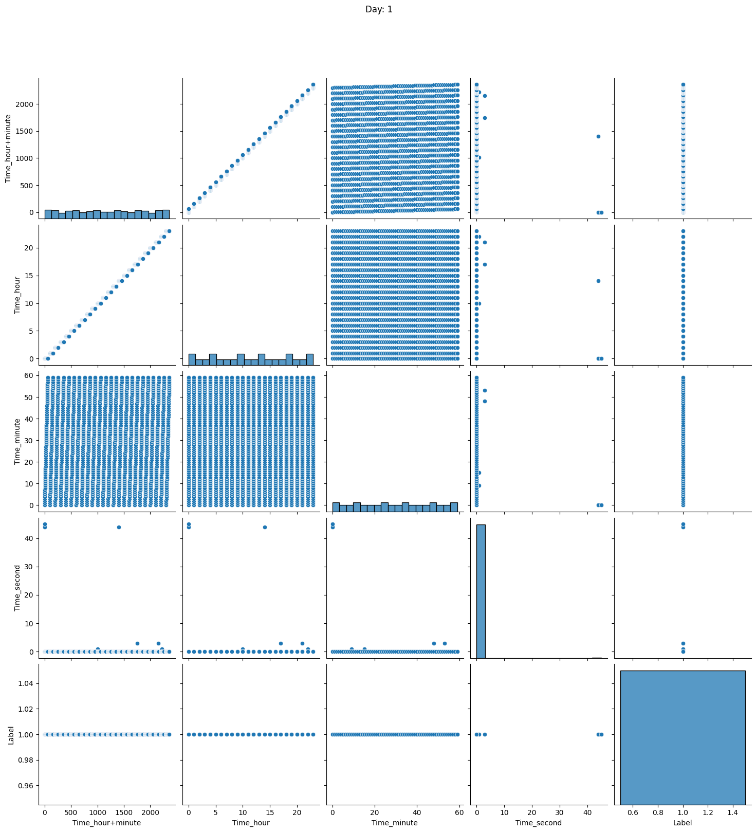

Figure 28: Day 3, 4, 5, & 6 traffic (non anomalous and anomalous)

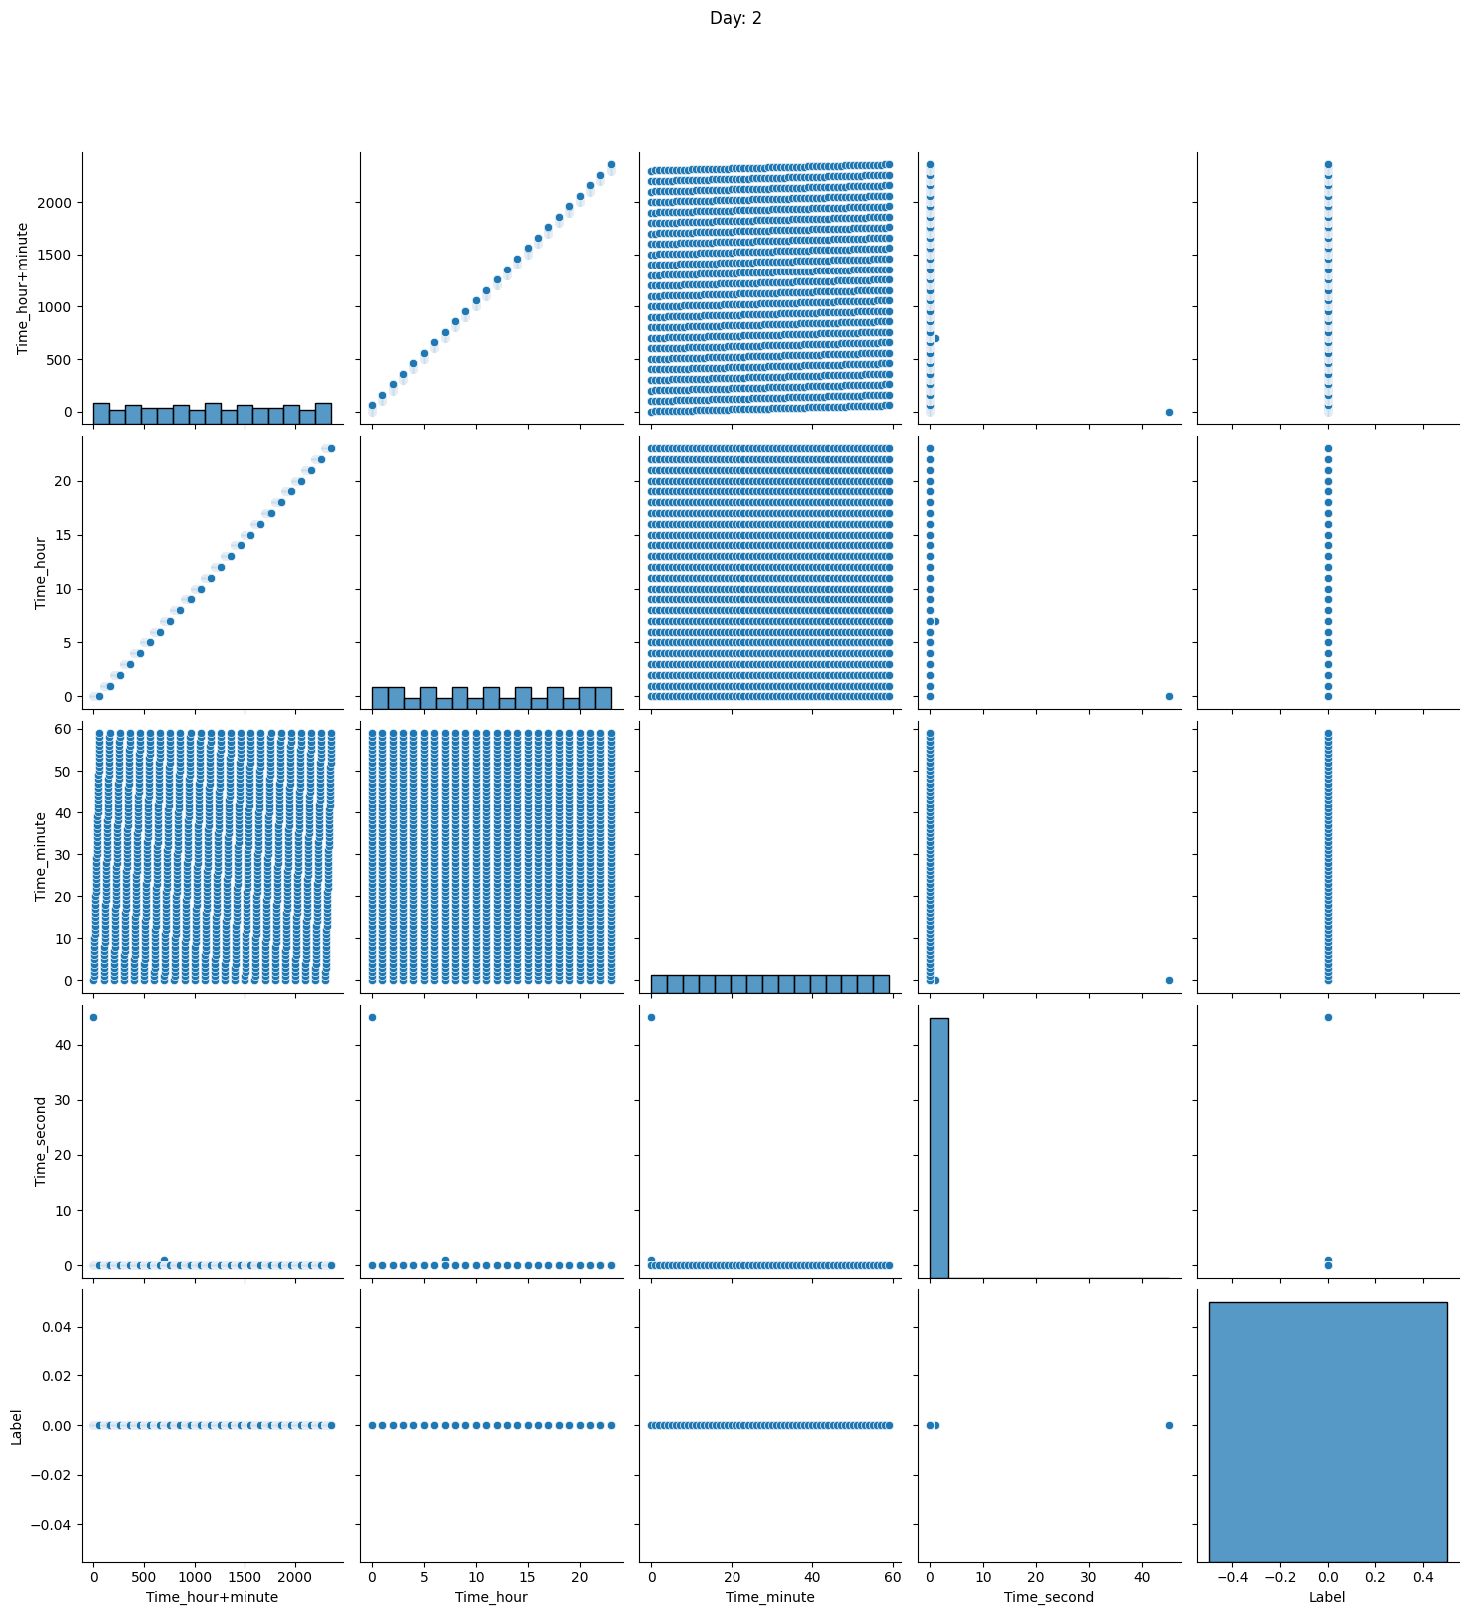

Figure 29: Day 7 & 8 traffic (non anomalous)